Container positioning for inspection

COHAOR
CONTAINER SPECIAL HANDLING MESSAGE

<!Fòrum telemàtic>

GUIDELINE FOR THE XML
COHAOR MESSAGE

Version 1.5

Message: COHAOR
Version: 1.5
Date: March 2011
Source: Portic Barcelona

CHANGE CONTROL

Version 1.5 includes the following changes to the previous version 1.4b from March 2010 (changes named
from P1 to P6 were agreed at the working group meeting from 13th May 2010 and changes from P7 to P15
were agreed at the working group meeting from 23th June 2010):

- In the section of “choreography” it has been added a new use for COHAOR message with code
“846” at DE1001. When the SCPP knows that the received information has some mistakes that
can be solved replacing the information received by the correct one, the SCPP can update in its
system the information received and then, a message can be sent to the customs broker with the
information present in the SCPP system and a copy can also be sent to the container terminal.

- (P1) A new code has been included for DE1001 of segment BGM:
- [844] “Express Inspection Request”. This positioning modality may only be applied for
several types of inspections (i.e. Border Inspection Post or Non Intrusive Inspections).
The choreography will be the same than for regular inspections but the system will assign
higher priority for these requests than the regular ones.

- (P5) It is mandatory to declare the “invoice” when someone should pay for the operation
requested.

- (P4) Several changes have been made to separate the location of the inspection from the requested
period for the positioning. On a previous version, the code for the location included the requested
period for positioning.
- At the DTM segment (Group 4) it has been included the possibility of declaring date and
time (since now, only the date was possible). DE2380 will include the time and DE2379
will include the new code “203” that means the format: “CCYYMMDDHHMM”. Time
will be used for identifying positioning periods and, for those, a convention will be
applied:
If the operator only can choose between mornings and afternoons:
• 08:00 will stand for the “morning period”
• 14:00 will stand for the “afternoon period”
If the day is divided in more periods, the starting time of the period will be
declared: i.e. if the period is from 11:00 to 14:00, it has to be declared 11:00.

- At the DE3225 of the LOC segment (Group 4) it has been removed several codes that
were used for afternoon positioning.

- (P13) In the “Inspection instructions message” or the “Communication about a previous scheduled
inspection message” from scenarios 1 and 2, and in the “rejection message” defined in scenario 2
it has included the possibility of including some comments. For this purpose, a new occurrence of
segment FTX at header level has been included with “AFB” in data element 4451.

- (P16) When a regulatory body requests the inspection of a goods item that is less than the
container load it could be necessary to declare the total weight of the container and the total
number of packages contained inside the equipment.
A second occurrence of segment MEA with “AAD” qualifier could be used for declaring the total
gross weight and segment CNT could be used with the total number of packages contained in the
LCL container.

Version 1.4b includes the following changes to the previous version 1.4 from November 2009:

- Code [Z29] “Guardia Civil” has been deleted from data element 1153 of segment RFF (Group 4).

Version 1.4 includes the following changes to the previous version 1.3 from May 2009:

- PDI inspections are performed in a special area and this area has to be included in DE3225 from LOC segment (group 4) as [PDI]. And PDI will be deleted as a service (code [Z31]) from DE1153 from segment RFF (group 4).
- A new inspection area has been included: [BRT] for Barcelona Reefer Terminal.
- Break bulk cargo can be declared in this message using the prefix “BULK” followed by the weight of the goods item, instead of the container number.
- When cargo it is not containerized and the inspection has to be performed on a special area of the Port, several data will not be mandatory and they would be only optional: shipping agent, vessel details, ship’s call number, place of origin (terminal),…

Version 1.3 is the first version of this user guide.

TABLE OF CONTENTS

GENERAL INTRODUCTION 5
CHOREOGRAPHY 6
BRANCHING DIAGRAM 9
MESSAGE DESCRIPTION 11
SCHEMA 55
DTD 67
EXAMPLE 69

GENERAL INTRODUCTION

FORMAL DEFINITION

COHAOR: “Order to perform a specified special handling and/or service on containers. This message is part of a total set of container-related messages. These messages serve to facilitate the intermodal handling of containers by streamlining the information exchange. The business scenario for the container messages is clarified in a separate document, called: 'Guide to the scenario of EDIFACT container messages'.”

The ‘Guide to the scenario of the EDIFACT container messages’ has been published by ITIGG under the title “Guide to the UN/EDIFACT Container Messages” (Document reference JM4/ITIGG/96.103/v.12).

CLARIFICATION

The COHAOR message is an order to perform specified special handling and/or services on items of transport equipment.

It is intended to be used in conjunction with a release order message - either a COPARN (empty container release) or COREOR (full container release) - in which case it would usually follow the release order, where the container in question had already been identified.

The COHAOR message contains more detailed specific instructions for special handling and/or servicing of the container.

UN/EDIFACT DIRECTORY REFERENCE

This document is based on the UN/EDIFACT D00B directory.

CHOREOGRAPHY

This message could be interchanged in two different scenarios. The fist one is an scenario where the Positioning Coordinator Service (SCPP) manages the resources needed for the inspections and assign the dates and hours for those inspections. That happens when the inspection is executed at the Border Inspection Service (BIP or PIF in Spanish) or when it is realized at the Non Intrusive Inspection (NII) area of the port.

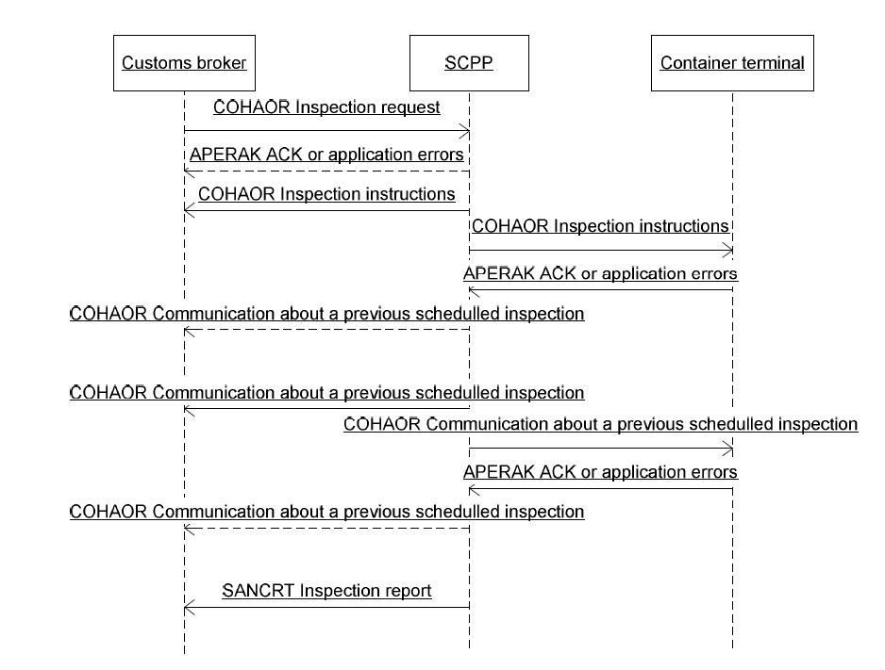

Fig. 1 Inspection at the Border Inspection Post or at the Non Intrusive Inspection area

In this scenario, the customs broker request for an inspection to the SCPP (COHAOR message with code “292” at DE1001) and the SCPP assigns some resources and a date for the inspection (COHAOR message with code “845” at DE1001). If some formal errors are detected, an APERAK message will be send, instead of the COHAOR message (this APERAK message is detailed on the ESMT – inbound and outbound land- procedure). A copy of this message is sent to the container terminal (COHAOR message with code “845” at DE1001) that can acknowledge the reception of this message or can answer with an error response if the container will not be at the terminal at the specified date (APERAK message).
If the container terminal rejects the informative message received, the SCPP can modify the scheduled date and propose a new one. The SCPP will send a message to the customs broker proposing a new date (1st use of the COHAOR message with code “846” at DE1001). After that, the new date has to be communicated to the container terminal and the answer could be in the same way that has been described before.
If the SCPP knows that the resources will not be available at the given date, the SCPP will send a message to the customs broker proposing a new date (2nd use of the COHAOR message with code “846” at DE1001) and must also send a copy to the container terminal (COHAOR message with code “846” at DE1001).
Sometimes the SCPP knows that the received information has some mistakes that can be solved replacing the information received by the correct one and the SCPP can update in its system the information received and can send a message to the customs broker with the information present in its system (3rd use of the COHAOR message with code “846” at DE1001) and must also send a copy to the container terminal (COHAOR message with code “846” at DE1001).
When the inspection has finalized, a message will be sent from the SCPP to the custom broker notifying this event (SANCRT message).

The second scenario is when the inspection will be executed at the container terminal yard. In this scenario the container terminal manages the necessary resources for the inspections and assigns dates and hours for those inspections. The Coordination Inspection Service must receive copy of all the interchanged messages.
In this scenario, the customs broker requests for an inspection to the shipping agent (COHAOR message with code “292” at DE1001) and the shipping agent relays this message to the container terminal and the SCPP (COHAOR message with code “292” at DE1001). The customs broker must also send a copy of this message to the SCPP (COHAOR message with code “292” at DE1001).
The container terminal assigns some resources and sends a message to the shipping agent with the date for the inspection (COHAOR message with code “845” at DE1001). It may not accept the request for inspection when the container will not be at the terminal (COHAOR message with code “845” at DE1001 and code “27” at DE1225). The shipping agent must send a copy of this message to the customs bróker (COHAOR message with code “845” at DE1001) and he also must send a copy to the SCPP (COHAOR message with code “845” at DE1001).
The custom broker, the shipping agent and the container terminal can agree the possibility of a direct communication from the customs broker to the container terminal. In this scenario, the shipping agent will be informed of the operations requested by the custom brokers.
When the container terminal knows that, at the given date, the container will not be positioned at the inspection area, it must send a message to the customs broker proposing a new date (COHAOR message with code “846” at DE1001) and must also sent a copy to the SCPP (COHAOR message with code “846” at DE1001).

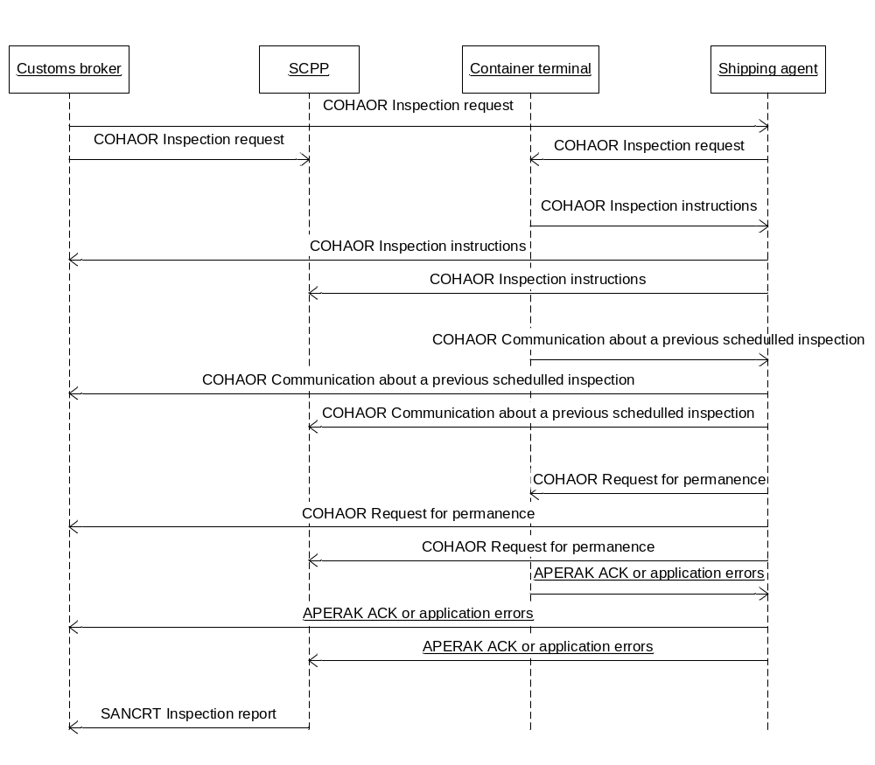
Fig. 2 Inspection at a specific area of the container terminal

For a positioned container, if it has not been possible to inspect during the day, the shipping agent can request for the permanence of the container at the inspection area (COHAOR message with code “847” at DE1001). The container terminal may acknowledge the reception of this message or may reject this operation when it will not have the resources for doing it (APERAK message).
When the inspection has finalized, a message will be sent from the SCPP to the custom broker notifying the event (SANCRT message).

BRANCHING DIAGRAM

This is a diagram of the COHAOR message schema. Since there are many elements in the message, the diagram shows only the most relevant elements:
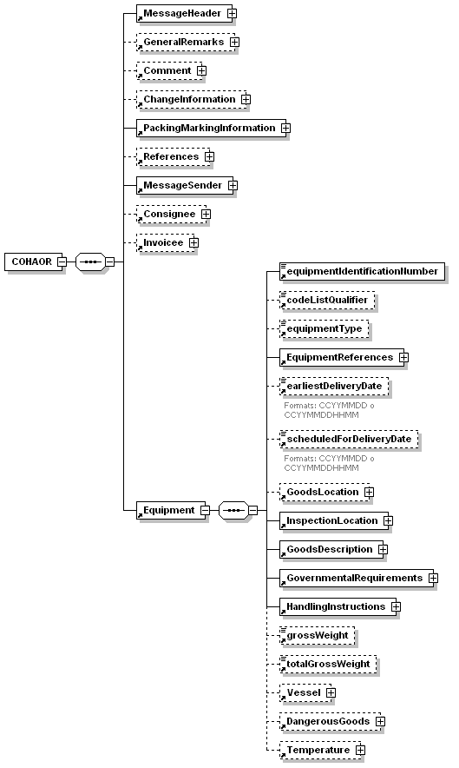

MESSAGE DESCRIPTION

This section is a detailed description of all the elements in the COHAOR message.

It is very important to generate correctly the first two lines of the xml message (encoding and DTD). There are five combinations, depending on the type of COHAOR. Here are the examples:

COHAOR292: Inspection request
<?xml version="1.0" encoding="ISO-8859-1"?>
<!DOCTYPE COHAOR292 SYSTEM "COHAOR.dtd">

COHAOR845: Inspection instruction
<?xml version="1.0" encoding="ISO-8859-1"?>
<!DOCTYPE COHAOR845 SYSTEM "COHAOR.dtd">

COHAOR846: Communication about a previous scheduled inspection
<?xml version="1.0" encoding="ISO-8859-1"?>
<!DOCTYPE COHAOR846 SYSTEM "COHAOR.dtd">

COHAOR847: Request for permanence at the inspection area
<?xml version="1.0" encoding="ISO-8859-1"?>
<!DOCTYPE COHAOR847 SYSTEM "COHAOR.dtd">

COHAOR844: Request for Express Inspection
<?xml version="1.0" encoding="ISO-8859-1"?>
<!DOCTYPE COHAOR844 SYSTEM "COHAOR.dtd">

This is the detailed description of all the elements of the COHAOR message.

element COHAOR

diagram | 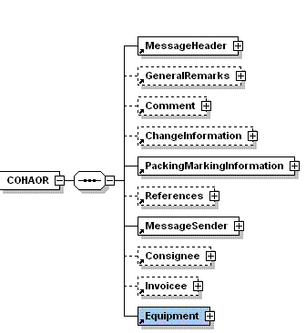
properties
  content | complex
children | MessageHeader GeneralRemarks Comment ChangeInformation PackingMarkingInformation References MessageSender Consignee Invoicee Equipment
source | <xs:element name="COHAOR">  <xs:complexType>  <xs:sequence>  <xs:element ref="MessageHeader"/>  <xs:element ref="GeneralRemarks" minOccurs="0"/>  <xs:element ref="Comment" minOccurs="0"/>  <xs:element ref="ChangeInformation" minOccurs="0"/>  <xs:element ref="PackingMarkingInformation"/>  <xs:element ref="References" minOccurs="0"/>  <xs:element ref="MessageSender"/>  <xs:element ref="Consignee" minOccurs="0"/>  <xs:element ref="Invoicee" minOccurs="0"/>  <xs:element ref="Equipment"/>  </xs:sequence>  </xs:complexType>  </xs:element>

element MessageHeader

diagram | 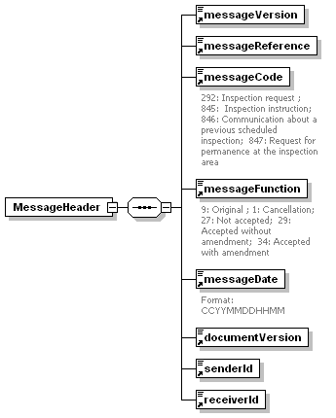
properties
  content | complex
children | messageVersion messageReference messageCode messageFunction messageDate documentVersion senderId receiverId
used by
  element | COHAOR
source | <xs:element name="MessageHeader">  <xs:complexType>  <xs:sequence>  <xs:element ref="messageVersion"/>  <xs:element ref="messageReference"/>  <xs:element ref="messageCode"/>  <xs:element ref="messageFunction"/>  <xs:element ref="messageDate"/>  <xs:element ref="documentVersion"/>  <xs:element ref="senderId"/>  <xs:element ref="receiverId"/>  </xs:sequence>  </xs:complexType>  </xs:element>

The following tables summarizes all the different combinations of sender, receiver, messageCode and messageFunction according to the implemented scenario:

1st scenario: Inspections at the Border Inspection Post or at the Non Intrusive Inspection area

Sender | Receiver | Description of the message | messageCode | messageFunction
Customs Broker | SCPP | Inspection request – Original | 292/844 | 9
SCPP | Container terminal | Inspection request – Original | 292/844 | 9
Customs Broker | SCPP | Inspection request – Cancelation | 292/844 | 1
SCPP | Container terminal | Inspection request – Cancelation | 292/844 | 1
SCPP | Customs Broker | Inspection instruction – Accepted without amendment | 845 | 29
SCPP | Container terminal | Inspection instruction – Accepted without amendment | 845 | 29
SCPP | Customs Broker | Inspection instruction – Accepted with amendment (change of proposed date) | 845 | 34
SCPP | Container terminal | Inspection instruction – Accepted with amendment (change of proposed date) | 845 | 34
SCPP | Customs Broker | Inspection instruction – Not accepted | 845 | 27
SCPP | Customs Broker | Communication on a previous scheduled inspection - Original | 846 | 9
SCPP | Container terminal | Communication on a previous scheduled inspection - Original | 846 | 9
SCPP | Customs Broker | Communication on a previous scheduled inspection - Cancelation | 846 | 1
SCPP | Container terminal | Communication on a previous scheduled inspection - Cancelation | 846 | 1

2nd scenario: Inspections at the terminal

Sender | Receiver | Description of the message | messageCode | messageFunction
Customs Broker | Shipping agent | Inspection request – Original | 292 | 9
Shipping agent | Container terminal | Inspection request – Original | 292 | 9
Shipping agent | SCPP | Inspection request – Original | 292 | 9
Customs Broker | Shipping agent | Inspection request – Cancelation | 292 | 1
Shipping agent | Container terminal | Inspection request – Cancelation | 292 | 1
Shipping agent | SCPP | Inspection request – Cancelation | 292 | 1
Container terminal | Shipping agent | Inspection instruction – Accepted without amendment | 845 | 29
Shipping agent | Customs Broker | Inspection instruction – Accepted without amendment | 845 | 29
Shipping agent | SCPP | Inspection instruction – Accepted without amendment | 845 | 29
Container terminal | Shipping agent | Inspection instruction – Accepted with amendment (change of proposed date) | 845 | 34
Shipping agent | Customs Broker | Inspection instruction – Accepted with amendment (change of proposed date) | 845 | 34
Shipping agent | SCPP | Inspection instruction – Accepted with amendment (change of proposed date) | 845 | 34
Container terminal | Shipping agent | Inspection instruction – Not accepted | 845 | 27
Shipping agent | Customs Broker | Inspection instruction – Not accepted | 845 | 27
Shipping agent | SCPP | Inspection instruction – Not accepted | 845 | 27
Container terminal | Shipping agent | Communication on a previous scheduled inspection - Original | 846 | 9
Shipping agent | Customs Broker | Communication on a previous scheduled inspection - Original | 846 | 9

Sender | Receiver | Description of the message | messageCode | messageFunction
Shipping agent | SCPP | Communication on a previous scheduled inspection - Original | 846 | 9
Container terminal | Shipping agent | Communication on a previous scheduled inspection - Cancelation | 846 | 1
Shipping agent | Customs Broker | Communication on a previous scheduled inspection - Cancelation | 846 | 1
Shipping agent | SCPP | Communication on a previous scheduled inspection - Cancelation | 846 | 1
Shipping agent | Container terminal | Request for permanence - Original | 847 | 9
Shipping agent | Customs Broker | Request for permanence - Original | 847 | 9
Shipping agent | SCPP | Request for permanence - Original | 847 | 9
Shipping agent | Container terminal | Request for permanence - Cancelation | 847 | 1
Shipping agent | Customs Broker | Request for permanence - Cancelation | 847 | 1
Shipping agent | SCPP | Request for permanence - Cancelation | 847 | 1

element messageVersion
diagram | 
type | restriction of xs:string
properties | UN/CEFACT directory
  content | simple
used by
  element | MessageHeader
facets
  enumeration | D00B
source | <xs:element name="messageVersion">  <xs:simpleType>  <xs:restriction base="xs:string">  <xs:enumeration value="D00B"/>  </xs:restriction>  </xs:simpleType>  </xs:element>
EDIFACT | Header , Segment UNH, elements 0052 and 0054

element messageReference
diagram | 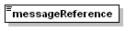
type | restriction of xs:string
properties | Number of message
  content | simple
used by
  element | MessageHeader
facets
  minLength | 1
  maxLength | 14
source | <xs:element name="messageReference">  <xs:simpleType>  <xs:restriction base="xs:string">  <xs:minLength value="1"/>  <xs:maxLength value="14"/>  </xs:restriction>  </xs:simpleType>  </xs:element>
EDIFACT | Header, Segment UNH, element 0062

element messageCode
diagram | 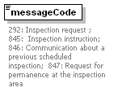
type | restriction of xs:string
properties | To indicate the type of a message and to transmit the identifying number.  292 Inspection request  A message requesting a party to inspect items.  [844] Express Inspection Request  A message requesting a party to inspect items immediately.  [845] Inspection instruction  A message notifying a party from the assigned instructions for an inspection.  [846] Communication about a previous scheduled inspection  A message from the party in charge of the management of the positioning for inspection giving new details for the scheduled inspection.  [847] Request for permanence at the inspection area  A message from the shipping agent to the terminal requesting the maintenance of the equipment at the inspection area of the terminal.
  content | simple
used by
  element | MessageHeader
facets
  enumeration | 292
  enumeration enumeration | 844  845
  enumeration | 846
  enumeration | 847
annotation
  documentation | 292: Inspection request ; 844:Express Inspection Request; 845: Inspection instruction; 846: Communication about a previous scheduled inspection; 847: Request for permanence at the inspection area
source | <xs:element name="messageCode">  <xs:annotation>  <xs:documentation>292: Inspection request ; 844:Express Inspection Request; 845: Inspection instruction; 846: Communication about a previous scheduled inspection; 847: Request for permanence at the inspection area</xs:documentation>  </xs:annotation>  <xs:simpleType>  <xs:restriction base="xs:string">  <xs:enumeration value="292"/>  <xs:enumeration value="844"/>  <xs:enumeration value="845"/>  <xs:enumeration value="846"/>  <xs:enumeration value="847"/>  </xs:restriction>  </xs:simpleType>  </xs:element>
EDIFACT | Header, Segment BGM, element 1001

element MessageFunction
diagram | 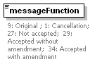
type | restriction of xs:string
properties | To indicate the function of the message:  When 1001 is “292” or “844”:  1 Cancellation (cancel whole message)  9 Original (whole new message)  When 1001 is “845”:  27 Not accepted  (only when the party notified is the sender of the inspection request)  29 Accepted without amendment  34 Accepted with amendment  When 1001 is “846”:  1 Cancellation (cancel whole message)  9 Original (whole new message)  When 1001 is “847”:  1 Cancellation (cancel whole message)  9 Original (whole new message)
  content | simple
used by
  element | MessageHeader
facets
  enumeration | 1
  enumeration | 9
  enumeration | 27
  enumeration | 29
  enumeration | 34
annotation
  documentation | 9: Original ; 1: Cancellation; 27: Not accepted; 29: Accepted without amendment; 34: Accepted with amendment
source | <xs:element name="messageFunction">  <xs:annotation>  <xs:documentation>9: Original ; 1: Cancellation; 27: Not accepted; 29: Accepted without amendment; 34: Accepted with amendment</xs:documentation>  </xs:annotation>  <xs:simpleType>  <xs:restriction base="xs:string">  <xs:enumeration value="1"/>  <xs:enumeration value="9"/>  <xs:enumeration value="27"/>  <xs:enumeration value="29"/>  <xs:enumeration value="34"/>  </xs:restriction>  </xs:simpleType>  </xs:element>
EDIFACT | Header, Segment BGM, element 1225

element messageDate

diagram | 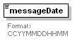
type | restriction of xs:string
properties | The DTM at this level can be used to specify dates related to the message.  Only one occurrence of this segment is used. The document/message send date is required.
  content | simple
used by
  element | MessageHeader
facets
  minLength | 12
  maxLength | 12
annotation
  documentation | Format: CCYYMMDDHHMM
source | <xs:element name="messageDate">  <xs:annotation>  <xs:documentation>Format: CCYYMMDDHHMM</xs:documentation>  </xs:annotation>  <xs:simpleType>  <xs:restriction base="xs:string">  <xs:minLength value="12"/>  <xs:maxLength value="12"/>  </xs:restriction>  </xs:simpleType>  </xs:element>
EDIFACT | Header, Segment DTM, element 2380

element documentVersion
diagram | 
type | restriction of xs:string
properties | Main document number. Sender's Unique Internal Reference Number  This is the identifier of the document. If the sender of a COHAOR document needs to send a cancellation of that document, he has to use the same documentVersion that was used in the original message.
  content | simple
used by
  element | MessageHeader
facets
  minLength | 1
  maxLength | 35
source | <xs:element name="documentVersion">  <xs:simpleType>  <xs:restriction base="xs:string">  <xs:minLength value="1"/>  <xs:maxLength value="35"/>  </xs:restriction>  </xs:simpleType>  </xs:element>
EDIFACT | Header , Segment BGM, element 1004

element senderId
diagram | 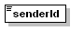
type | restriction of xs:string
properties | Identification of the sender of the document, coded. Composed by 2 letter country code plus the NIF of the company that sends the document. For example ESA61961488.
  content | simple
used by
  element | MessageHeader
facets
  minLength | 1
  maxLength | 35
source | <xs:element name="senderId">  <xs:simpleType>  <xs:restriction base="xs:string">  <xs:minLength value="1"/>  <xs:maxLength value="35"/>  </xs:restriction>  </xs:simpleType>  </xs:element>
EDIFACT | Header, Segment UNB, element 0004

element receiverId
diagram | 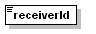
type | restriction of xs:string
properties | Identification of the receiver of the document, coded. Composed by 2 letter country code plus the NIF of the company receiver of the document. For example ESA61961488.
  content | simple
used by
  element | MessageHeader
facets
  minLength | 1
  maxLength | 35
source | <xs:element name="receiverId">  <xs:simpleType>  <xs:restriction base="xs:string">  <xs:minLength value="1"/>  <xs:maxLength value="35"/>  </xs:restriction>  </xs:simpleType>  </xs:element>
EDIFACT | Header, Segment UNB, element 0010

element GeneralRemarks

diagram | 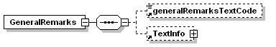
properties
  content | complex
children | generalRemarksTextCode TextInfo
used by
  element | COHAOR
source | <xs:element name="GeneralRemarks">  <xs:complexType>  <xs:sequence>  <xs:element ref="generalRemarksTextCode" minOccurs="0"/>  <xs:element ref="TextInfo" minOccurs="0"/>  </xs:sequence>  </xs:complexType>  </xs:element>

element generalRemarksTextCode
diagram | 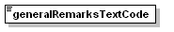
type | restriction of xs:string
properties | PX For operational purposes, only when cargo is palletized it must be used this data element with “AEA” in DE4451.
  content | simple
used by
  element | GeneralRemarks
facets
  enumeration | PX
source | <xs:element name="generalRemarksTextCode">  <xs:simpleType>  <xs:restriction base="xs:string">  <xs:enumeration value="PX"/>  </xs:restriction>  </xs:simpleType>  </xs:element>
EDIFACT | Header, Segment FTX, qualifier AEA, element 4441

element TextInfo
diagram | 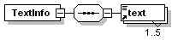
properties | In GeneralRemarks: General remarks referred to the container cargo, other than when the cargo is palletized.  In ChangeInformation: Information that has changed  In GoodsDescripcion: Coded or clear text information related to equipment. Description of goods
  content | complex
children | text
used by
  elements | GeneralRemarks Comment ChangeInformation GoodsDescription
source | <xs:element name="TextInfo">  <xs:complexType>  <xs:sequence>  <xs:element ref="text" maxOccurs="5"/>  </xs:sequence>  </xs:complexType>  </xs:element>
EDIFACT | In GeneralRemarks: Header, Segment FTX, qualifier AEA, element 4440
EDIFACT | In Comment: Header, Segment FTX, qualifier AFB, element 4440
EDIFACT | In ChangeInformation: Header, Segment FTX, qualifier CHG, element 4440
EDIFACT | In GoodsDescripcion: Group 4, Segment FTX, qualifier AAA, element 4440

element text
diagram | 
type | restriction of xs:string
properties
  content | simple
used by
  element | TextInfo
facets
  minLength | 1
  maxLength | 512
source | <xs:element name="text">  <xs:simpleType>  <xs:restriction base="xs:string">  <xs:minLength value="1"/>  <xs:maxLength value="512"/>  </xs:restriction>  </xs:simpleType>  </xs:element>

element Comment
diagram | 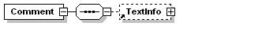
properties
  content | complex
children | TextInfo
used by
  element | COHAOR
source | <xs:element name="Comment">  <xs:complexType>  <xs:sequence>  <xs:element ref="TextInfo" minOccurs="0"/>  </xs:sequence>  </xs:complexType>  </xs:element>

element ChangeInformation
diagram | 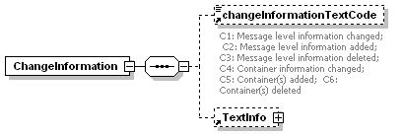
properties
  content | complex
children | changeInformationTextCode TextInfo
used by
  element | COHAOR
source | <xs:element name="ChangeInformation">  <xs:complexType>  <xs:sequence>  <xs:element ref="changeInformationTextCode" minOccurs="0"/>  <xs:element ref="TextInfo" minOccurs="0"/>  </xs:sequence>  </xs:complexType>  </xs:element>

element changeInformationTextCode
diagram | 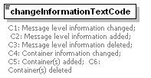
type | restriction of xs:string
properties | Change information  C1:Message level information changed  C2:Message level information added  C3:Message level information deleted  C4:Container information changed  C5:Container(s) added  C6:Container(s) deleted
  content | simple
used by
  element | ChangeInformation
facets
  enumeration | C1
  enumeration | C2
  enumeration | C3
  enumeration | C4
  enumeration | C5
  enumeration | C6
annotation
  documentation | C1: Message level information changed; C2: Message level information added; C3: Message level information deleted; C4: Container information changed; C5: Container(s) added; C6: Container(s) deleted
source | <xs:element name="changeInformationTextCode">  <xs:annotation>  <xs:documentation>C1: Message level information changed; C2: Message level information added; C3: Message level information deleted; C4: Container information changed; C5: Container(s) added; C6: Container(s) deleted</xs:documentation>  </xs:annotation>  <xs:simpleType>  <xs:restriction base="xs:string">  <xs:enumeration value="C1"/>  <xs:enumeration value="C2"/>  <xs:enumeration value="C3"/>  <xs:enumeration value="C4"/>  <xs:enumeration value="C5"/>  <xs:enumeration value="C6"/>  </xs:restriction>  </xs:simpleType>  </xs:element>
EDIFACT | Header, Segment FTX, qualifier CHG, element 4441

element PackingMarkingInformation
diagram | 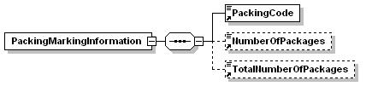
properties
  content | complex
children | PackingCode NumberOfPackages TotalNumberOfPackages
used by
  element | COHAOR
source | <xs:element name="PackingMarkingInformation">  <xs:complexType>  <xs:sequence>  <xs:element ref="PackingCode"/>  <xs:element ref="NumberOfPackages" minOccurs="0"/>  <xs:element ref="TotalNumberOfPackages" minOccurs="0"/>  </xs:sequence>  </xs:complexType>  </xs:element>

element PackingCode
diagram | 
type | restriction of xs:string
properties | Use UN/ECE Recommendation number 21 (2 alpha code), e.g. “SA” Sack.
  content | simple
used by
  element | PackingMarkingInformation
facets
  minLength | 1
  maxLength | 17
source | <xs:element name="PackingCode">  <xs:simpleType>  <xs:restriction base="xs:string">  <xs:minLength value="1"/>  <xs:maxLength value="17"/>  </xs:restriction>  </xs:simpleType>  </xs:element>
EDIFACT | Header, Segment FTX, qualifier PAC, element 4441

element NumberOfPackages
diagram | 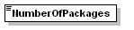
type | restriction of xs:string
properties | Number of packages to be inspected in the container.
  content | simple
used by
  element | PackingMarkingInformation
facets
  minLength | 1
  maxLength | 17
source | <xs:element name="NumberOfPackages">  <xs:simpleType>  <xs:restriction base="xs:string">  <xs:minLength value="1"/>  <xs:maxLength value="17"/>  </xs:restriction>  </xs:simpleType>  </xs:element>
EDIFACT | Header, Segment FTX, qualifier PAC, element 4440

element TotalNumberOfPackages
diagram | 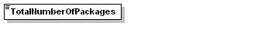
type | restriction of xs:string
properties | Total number of packages in the container.  For LCL containers, this element is required.
  content | simple
used by
  element | PackingMarkingInformation
facets
  minLength | 1
  maxLength | 17
source | <xs:element name="TotalNumberOfPackages">  <xs:simpleType>  <xs:restriction base="xs:string">  <xs:minLength value="1"/>  <xs:maxLength value="17"/>  </xs:restriction>  </xs:simpleType>  </xs:element>
EDIFACT | Header, Segment CNT, element 6066

element References
diagram | 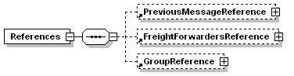
properties
  content | complex
children | PreviousMessageReference FreightForwardersReference GroupReference
used by
  element | COHAOR
source | <xs:element name="References">  <xs:complexType>  <xs:sequence>  <xs:element ref="PreviousMessageReference" minOccurs="0"/>  <xs:element ref="FreightForwardersReference" minOccurs="0"/>  <xs:element ref="GroupReference" minOccurs="0"/>  </xs:sequence>  </xs:complexType>  </xs:element>

element PreviousMessageReference
diagram
properties | Reference to a previous message  Must be used when the document/message name (DE1001 in segment BGM)is other than “292” and the message function (DE1225 in segment 2005) is other than Original (e.g. in case of a replacement message). In both situations, a reference to the previous message has to be sent in the data element 1154 of this segment and the reference has to be the document/message number (DE1004 in segment BGM of the previous message).  When the SCPP has received the request for an inspection manually (in a paper form, because the sender was not able to send an EDI message) this number will start with the string “MANUAL”.
  content | complex
children | previousMessageReferenceNumber
used by
  element | References
source | <xs:element name="PreviousMessageReference">  <xs:complexType>  <xs:sequence>  <xs:element ref="previousMessageReferenceNumber"/>  </xs:sequence>  </xs:complexType>  </xs:element>
EDIFACT | Group 1, Segment RFF, qualifier ACW element 1154

element previousMessageReferenceNumber
diagram | 
type | restriction of xs:string
properties
  content | simple
used by
  element | PreviousMessageReference
facets
  minLength | 1
  maxLength | 35
source | <xs:element name="previousMessageReferenceNumber">  <xs:simpleType>  <xs:restriction base="xs:string">  <xs:minLength value="1"/>  <xs:maxLength value="35"/>  </xs:restriction>  </xs:simpleType>  </xs:element>

element FreightForwardersReference
diagram
properties | Freight forwarder's reference number  When the container indicated in this message has to be inspected together with other/s container/s, this reference will link this message to the messages of the other containers.
  content | complex
children | freightForwardersReferenceNumber
used by
  element | References
source | <xs:element name="FreightForwardersReference">  <xs:complexType>  <xs:sequence>  <xs:element ref="freightForwardersReferenceNumber"/>  </xs:sequence>  </xs:complexType>  </xs:element>
EDIFACT | Group 1, Segment RFF, qualifier FF element 1154

element freightForwardersReferenceNumber
diagram | 
type | restriction of xs:string
properties
  content | simple
used by
  element | FreightForwardersReference
facets
  minLength | 1
  maxLength | 35
source | <xs:element name="freightForwardersReferenceNumber">  <xs:simpleType>  <xs:restriction base="xs:string">  <xs:minLength value="1"/>  <xs:maxLength value="35"/>  </xs:restriction>  </xs:simpleType>  </xs:element>

element GroupReference
diagram | 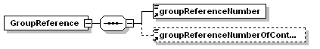
properties
  content | complex
children | groupReferenceNumber groupReferenceNumberOfContainers
used by
  element | References
source | <xs:element name="GroupReference">  <xs:complexType>  <xs:sequence>  <xs:element ref="groupReferenceNumber"/>  <xs:element ref="groupReferenceNumberOfContainers" minOccurs="0"/>  </xs:sequence>  </xs:complexType>  </xs:element>

element groupReferenceNumber
diagram | 
type | restriction of xs:string
properties | Group reference number  When several containers have to be inspected together, it must be declared the number that identifies these group of containers.
  content | simple
used by
  element | GroupReference
facets
  minLength | 1
  maxLength | 35
source | <xs:element name="groupReferenceNumber">  <xs:simpleType>  <xs:restriction base="xs:string">  <xs:minLength value="1"/>  <xs:maxLength value="35"/>  </xs:restriction>  </xs:simpleType>  </xs:element>
EDIFACT | Group 1, Segment RFF, qualifier AST element 1154

element groupReferenceNumberOfContainers
diagram | 
type | restriction of xs:string
properties | When several containers have to be inspected together, it must be declared the total number of containers
  content | simple
used by
  element | GroupReference
facets
  minLength | 1
  maxLength | 6
source | <xs:element name="groupReferenceNumberOfContainers">  <xs:simpleType>  <xs:restriction base="xs:string">  <xs:minLength value="1"/>  <xs:maxLength value="6"/>  </xs:restriction>  </xs:simpleType>  </xs:element>
EDIFACT | Group 1, Segment RFF, qualifier AST element 1156

element MessageSender

diagram | 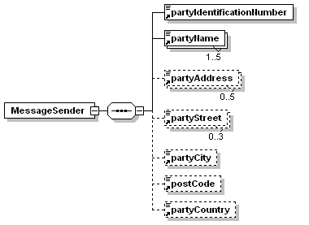
properties | Message Sender  The MessageSender element at this level must always be sent. It identifies parties associated with the equipment release(s) transmitted in the message.
  content | complex
children | partyIdentificationNumber partyName partyAddress partyStreet partyCity postCode partyCountry
used by
  element | COHAOR
source | <xs:element name="MessageSender">  <xs:complexType>  <xs:sequence>  <xs:element ref="partyIdentificationNumber"/>  <xs:element ref="partyName" maxOccurs="5"/>  <xs:element ref="partyAddress" minOccurs="0" maxOccurs="5"/>  <xs:element ref="partyStreet" minOccurs="0" maxOccurs="3"/>  <xs:element ref="partyCity" minOccurs="0"/>  <xs:element ref="postCode" minOccurs="0"/>  <xs:element ref="partyCountry" minOccurs="0"/>  </xs:sequence>  </xs:complexType>  </xs:element>

element partyIdentificationNumber
diagram | 
type | restriction of xs:string
properties | Party’s NIF/CIF
  content | simple
used by
  elements | MessageSender Consignee Invoicee
facets
  minLength | 1
  maxLength | 35
source | <xs:element name="partyIdentificationNumber">  <xs:simpleType>  <xs:restriction base="xs:string">  <xs:minLength value="1"/>  <xs:maxLength value="35"/>  </xs:restriction>  </xs:simpleType>  </xs:element>
EDIFACT | Group 2 , Segment NAD, element 3039

element partyName
diagram | 
type | restriction of xs:string
properties | Party name
  content | simple
used by
  elements | MessageSender Consignee Invoicee
facets
  minLength | 1
  maxLength | 35
source | <xs:element name="partyName">  <xs:simpleType>  <xs:restriction base="xs:string">  <xs:minLength value="1"/>  <xs:maxLength value="35"/>  </xs:restriction>  </xs:simpleType>  </xs:element>
EDIFACT | Group 2 , Segment NAD, element 3036

element partyAddress
diagram | 
type | restriction of xs:string
properties | Name and address line
  content | simple
used by
  elements | MessageSender Consignee Invoicee
facets
  minLength | 1
  maxLength | 35
source | <xs:element name="partyAddress">  <xs:simpleType>  <xs:restriction base="xs:string">  <xs:minLength value="1"/>  <xs:maxLength value="35"/>  </xs:restriction>  </xs:simpleType>  </xs:element>
EDIFACT | Group 2 , Segment NAD, element 3124

element partyStreet
diagram | 
type | restriction of xs:string
properties | Street and number/p.o. box
  content | simple
used by
  elements | MessageSender Consignee Invoicee
facets
  minLength | 1
  maxLength | 35
source | <xs:element name="partyStreet">  <xs:simpleType>  <xs:restriction base="xs:string">  <xs:minLength value="1"/>  <xs:maxLength value="35"/>  </xs:restriction>  </xs:simpleType>  </xs:element>
EDIFACT | Group 2 , Segment NAD, element 3042

element partyCity
diagram | 
type | restriction of xs:string
properties | CITY NAME
  content | simple
used by
  elements | MessageSender Consignee Invoicee
facets
  minLength | 1
  maxLength | 35
source | <xs:element name="partyCity">  <xs:simpleType>  <xs:restriction base="xs:string">  <xs:minLength value="1"/>  <xs:maxLength value="35"/>  </xs:restriction>  </xs:simpleType>  </xs:element>
EDIFACT | Group 2 , Segment NAD, element 3164

element postCode
diagram | 
type | restriction of xs:string
properties
  content | simple
used by
  elements | MessageSender Consignee Invoicee
facets
  minLength | 1
  maxLength | 9
source | <xs:element name="postCode">  <xs:simpleType>  <xs:restriction base="xs:string">  <xs:minLength value="1"/>  <xs:maxLength value="9"/>  </xs:restriction>  </xs:simpleType>  </xs:element>
EDIFACT | Group 2, Segment NAD, element 3251

element partyCountry
diagram | 
type | restriction of xs:string
properties | COUNTRY, CODED
  content | simple
used by
  elements | MessageSender Consignee Invoicee
facets
  minLength | 1
  maxLength | 3
source | <xs:element name="partyCountry">  <xs:simpleType>  <xs:restriction base="xs:string">  <xs:minLength value="1"/>  <xs:maxLength value="3"/>  </xs:restriction>  </xs:simpleType>  </xs:element>
EDIFACT | Group 2 , Segment NAD, element 3207

element Consignee
diagram | 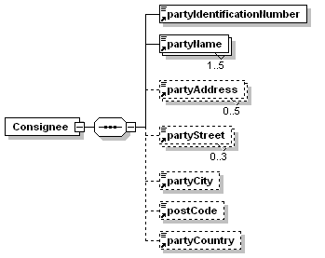
properties | Consignee (in this message implementation guidelines, this code is used for the shipping agent details)  Consignee (in this message implementation guidelines, this code is used for the shipping agent details). Mandatory for containerized cargo.
  content | complex
children | partyIdentificationNumber partyName partyAddress partyStreet partyCity postCode partyCountry
used by
  element | COHAOR
source | <xs:element name="Consignee">  <xs:complexType>  <xs:sequence>  <xs:element ref="partyIdentificationNumber"/>  <xs:element ref="partyName" maxOccurs="5"/>  <xs:element ref="partyAddress" minOccurs="0" maxOccurs="5"/>  <xs:element ref="partyStreet" minOccurs="0" maxOccurs="3"/>  <xs:element ref="partyCity" minOccurs="0"/>  <xs:element ref="postCode" minOccurs="0"/>  <xs:element ref="partyCountry" minOccurs="0"/>  </xs:sequence>  </xs:complexType>  </xs:element>

element Invoicee
diagram | 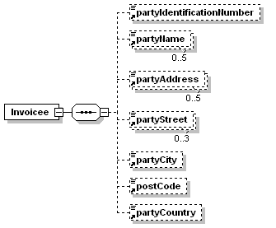
properties | Invoicee (must be sent where the message sender differs from the invoicee)
  content | complex
children | partyIdentificationNumber partyName partyAddress partyStreet partyCity postCode partyCountry
used by
  element | COHAOR
source | <xs:element name="Invoicee">  <xs:complexType>  <xs:sequence>  <xs:element ref="partyIdentificationNumber" minOccurs="0"/>  <xs:element ref="partyName" minOccurs="0" maxOccurs="5"/>  <xs:element ref="partyAddress" minOccurs="0" maxOccurs="5"/>  <xs:element ref="partyStreet" minOccurs="0" maxOccurs="3"/>  <xs:element ref="partyCity" minOccurs="0"/>  <xs:element ref="postCode" minOccurs="0"/>  <xs:element ref="partyCountry" minOccurs="0"/>  </xs:sequence>  </xs:complexType>  </xs:element>

element Equipment
diagram | 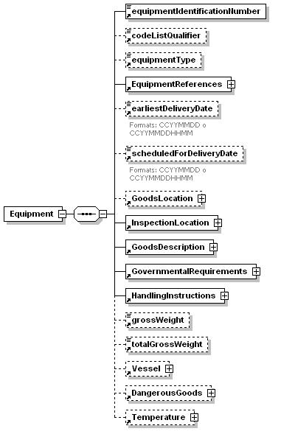
properties | A group to specify the containers to be released.  GoodsLocation and InspectionLocation are mandatory for containerized cargo  When cargo is not containerized, only InspectionLocation must be sent.
  content | complex
children | equipmentIdentificationNumber codeListQualifier equipmentType EquipmentReferences earliestDeliveryDate scheduledForDeliveryDate GoodsLocation InspectionLocation GoodsDescription GovernmentalRequirements HandlingInstructions grossWeight totalGrossWeight Vessel DangerousGoods Temperature
used by
  element | COHAOR
Source | <xs:element name="Equipment">  <xs:complexType>  <xs:sequence>  <xs:element ref="equipmentIdentificationNumber"/>  <xs:element ref="codeListQualifier" minOccurs="0"/>  <xs:element ref="equipmentType" minOccurs="0"/>  <xs:element ref="EquipmentReferences"/>  <xs:element ref="earliestDeliveryDate" minOccurs="0"/>  <xs:element ref="scheduledForDeliveryDate" minOccurs="0"/>  <xs:element ref="GoodsLocation" minOccurs="0"/>  <xs:element ref="InspectionLocation"/>  <xs:element ref="GoodsDescription"/>  <xs:element ref="GovernmentalRequirements"/>  <xs:element ref="HandlingInstructions"/>  <xs:element ref="grossWeight" minOccurs="0"/>  <xs:element ref="totalGrossWeight" minOccurs="0"/>  <xs:element ref="Vessel" minOccurs="0"/>  <xs:element ref="DangerousGoods" minOccurs="0"/>  <xs:element ref="Temperature" minOccurs="0"/>  </xs:sequence>  </xs:complexType>  </xs:element>

element equipmentIdentificationNumber
diagram | 
type | restriction of xs:string
properties | Equipment Number  Container numbers must include both prefix and number, expressed as a contiguous string without spaces or hyphens.  Break bulk identification  For break bulk cargo it must be used the following string: “BULK” plus the weight of the goods item expressed in Kgr., as a contiguous string without spaces or hyphens. E.g. “BULK25” when its weight is 25 Kgr. and “BULK1200” if its weight is 1,200 Kgr.
  content | simple
used by
  element | Equipment
facets
  minLength | 1
  maxLength | 17
source | <xs:element name="equipmentIdentificationNumber">  <xs:simpleType>  <xs:restriction base="xs:string">  <xs:minLength value="1"/>  <xs:maxLength value="17"/>  </xs:restriction>  </xs:simpleType>  </xs:element>
EDIFACT | Group 4, Segment EQD, element 8260

element codeListQualifier
diagram | 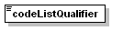
type | restriction of xs:string
properties | 55: Quality conformance  Use this code when the equipment identification number is ISO6346 compliant and the control digit is calculated according to this standard. Otherwise, skip this data element.
  content | simple
used by
  element | Equipment
facets
  enumeration | 55
source | <xs:element name="codeListQualifier">  <xs:simpleType>  <xs:restriction base="xs:string">  <xs:enumeration value="55"/>  </xs:restriction>  </xs:simpleType>  </xs:element>
EDIFACT | Group 4, Segment EQD, element 1131

element equipmentType
diagram | 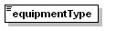
type | restriction of xs:string
properties | Equipment Size and type  Container size and type according to ISO6346 codes.  Use this code when it is containerized cargo.
  content | simple
used by
  element | Equipment
facets
  minLength | 1
  maxLength | 10
source | <xs:element name="equipmentType">  <xs:simpleType>  <xs:restriction base="xs:string">  <xs:minLength value="1"/>  <xs:maxLength value="10"/>  </xs:restriction>  </xs:simpleType>  </xs:element>
EDIFACT | Group 4, Segment EQD, element 8155

element EquipmentReferences
diagram | 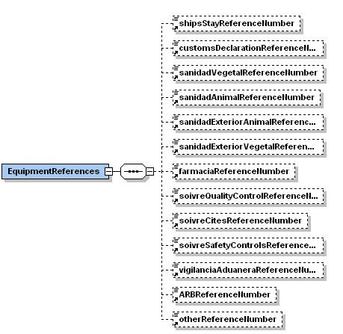
properties
  content | complex
children | shipsStayReferenceNumber customsDeclarationReferenceNumber sanidadVegetalReferenceNumber sanidadAnimalReferenceNumber sanidadExteriorAnimalReferenceNumber sanidadExteriorVegetalReferenceNumber farmaciaReferenceNumber soivreQualityControlReferenceNumber soivreCitesReferenceNumber soivreSafetyControlsReferenceNumber vigilanciaAduaneraReferenceNumber ARBReferenceNumber otherReferenceNumber
used by
  element | Equipment
source | <xs:element name="EquipmentReferences">  <xs:complexType>  <xs:sequence>  <xs:element ref="shipsStayReferenceNumber" minOccurs="0"/>  <xs:element ref="customsDeclarationReferenceNumber" minOccurs="0"/>  <xs:element ref="sanidadVegetalReferenceNumber" minOccurs="0"/>  <xs:element ref="sanidadAnimalReferenceNumber" minOccurs="0"/>  <xs:element ref="sanidadExteriorAnimalReferenceNumber" minOccurs="0"/>  <xs:element ref="sanidadExteriorVegetalReferenceNumber" minOccurs="0"/>  <xs:element ref="farmaciaReferenceNumber" minOccurs="0"/>  <xs:element ref="soivreQualityControlReferenceNumber" minOccurs="0"/>  <xs:element ref="soivreCitesReferenceNumber" minOccurs="0"/>  <xs:element ref="soivreSafetyControlsReferenceNumber" minOccurs="0"/>  <xs:element ref="vigilanciaAduaneraReferenceNumber" minOccurs="0"/>  <xs:element ref="ARBReferenceNumber" minOccurs="0"/>  <xs:element ref="otherReferenceNumber" minOccurs="0"/>  </xs:sequence>  </xs:complexType>  </xs:element>

element shipsStayReferenceNumber
diagram | 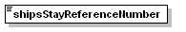
type | restriction of xs:string
properties | Ship's stay reference number  Mandatory for containerized cargo.  Reference number assigned by a port authority to the stay of a vessel in the port.  For goods unloaded at the Port, even if they are going to be transshipped to another vessel, it must be declared the ship’s stay reference of the vessel from where the goods have been unloaded.  For goods that will be loaded at the Port, only if they do not proceed from a transshipment from another vessel, it must be declared the ship’s stay reference of the vessel to where the goods will be loaded.
  content | simple
used by
  element | EquipmentReferences
facets
  minLength | 1
  maxLength | 35
source | <xs:element name="shipsStayReferenceNumber">  <xs:simpleType>  <xs:restriction base="xs:string">  <xs:minLength value="1"/>  <xs:maxLength value="35"/>  </xs:restriction>  </xs:simpleType>  </xs:element>
EDIFACT | Group 4, Segment RFF, qualifier ATZ, element 1154

element customsDeclarationReferenceNumber
diagram | 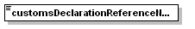
type | restriction of xs:string
properties | [Z05] Customs  Customs authorities.  Customs declaration number
  content | simple
used by
  element | EquipmentReferences
facets
  minLength | 1
  maxLength | 35
source | <xs:element name="customsDeclarationReferenceNumber">  <xs:simpleType>  <xs:restriction base="xs:string">  <xs:minLength value="1"/>  <xs:maxLength value="35"/>  </xs:restriction>  </xs:simpleType>  </xs:element>
EDIFACT | Group 4, Segment RFF, qualifier Z05, element 1154

element sanidadVegetalReferenceNumber
diagram | 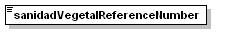
type | restriction of xs:string
properties | Sanidad Vegetal – Phytosanitary  Government agency responsible for the inspection of vegetable substances being imported.  Number of the request for phytosanitary controls (Sanidad Vegetal).
  content | simple
used by
  element | EquipmentReferences
facets
  minLength | 1
  maxLength | 35
source | <xs:element name="sanidadVegetalReferenceNumber">  <xs:simpleType>  <xs:restriction base="xs:string">  <xs:minLength value="1"/>  <xs:maxLength value="35"/>  </xs:restriction>  </xs:simpleType>  </xs:element>
EDIFACT | Group 4, Segment RFF, qualifier Z20, element 1154

element sanidadAnimalReferenceNumber
diagram | 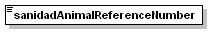
type | restriction of xs:string
properties | Sanidad Animal  Government agency responsible for the for the importation of live animals and for the inspection of animal food.  Number of the request for animal health safety controls (Sanidad Animal).
  content | simple
used by
  element | EquipmentReferences
facets
  minLength | 1
  maxLength | 35
source | <xs:element name="sanidadAnimalReferenceNumber">  <xs:simpleType>  <xs:restriction base="xs:string">  <xs:minLength value="1"/>  <xs:maxLength value="35"/>  </xs:restriction>  </xs:simpleType>  </xs:element>
EDIFACT | Group 4, Segment RFF, qualifier Z21, element 1154

element sanidadExteriorAnimalReferenceNumber
diagram | 
type | restriction of xs:string
properties | Sanidad Exterior – animal products  Government agency responsible for public health matters. Animal products.  Number of the request for public health safety controls (Sanidad Exterior).
  content | simple
used by
  element | EquipmentReferences
facets
  minLength | 1
  maxLength | 35
source | <xs:element name="sanidadExteriorAnimalReferenceNumber">  <xs:simpleType>  <xs:restriction base="xs:string">  <xs:minLength value="1"/>  <xs:maxLength value="35"/>  </xs:restriction>  </xs:simpleType>  </xs:element>
EDIFACT | Group 4, Segment RFF, qualifier Z22, element 1154

element sanidadExteriorVegetalReferenceNumber
diagram | 
type | restriction of xs:string
properties | Sanidad Exterior – vegetal products  Government agency responsible for public health matters. Vegetal products.  Number of the request for public health safety controls (Sanidad Exterior).
  content | simple
used by
  element | EquipmentReferences
facets
  minLength | 1
  maxLength | 35
source | <xs:element name="sanidadExteriorVegetalReferenceNumber">  <xs:simpleType>  <xs:restriction base="xs:string">  <xs:minLength value="1"/>  <xs:maxLength value="35"/>  </xs:restriction>  </xs:simpleType>  </xs:element>
EDIFACT | Group 4, Segment RFF, qualifier Z23, element 1154

element farmaciaReferenceNumber
diagram | 
type | restriction of xs:string
properties | Farmacia  Number of the request for pharmaceutical controls (Farmacia).
  content | simple
used by
  element | EquipmentReferences
facets
  minLength | 1
  maxLength | 35
source | <xs:element name="farmaciaReferenceNumber">  <xs:simpleType>  <xs:restriction base="xs:string">  <xs:minLength value="1"/>  <xs:maxLength value="35"/>  </xs:restriction>  </xs:simpleType>  </xs:element>
EDIFACT | Group 4, Segment RFF, qualifier Z24, element 1154

element soivreQualityControlReferenceNumber
diagram | 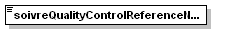
type | restriction of xs:string
properties | SOIVRE – Quality controls  Number of the request for commercial quality controls (SOIVRE).
  content | simple
used by
  element | EquipmentReferences
facets
  minLength | 1
  maxLength | 35
source | <xs:element name="soivreQualityControlReferenceNumber">  <xs:simpleType>  <xs:restriction base="xs:string">  <xs:minLength value="1"/>  <xs:maxLength value="35"/>  </xs:restriction>  </xs:simpleType>  </xs:element>
EDIFACT | Group 4, Segment RFF, qualifier Z25, element 1154

element soivreCitesReferenceNumber
diagram | 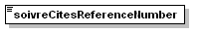
type | restriction of xs:string
properties | SOIVRE – CITES  Number of the request for commercial quality controls (SOIVRE).
  content | simple
used by
  element | EquipmentReferences
facets
  minLength | 1
  maxLength | 35
source | <xs:element name="soivreCitesReferenceNumber">  <xs:simpleType>  <xs:restriction base="xs:string">  <xs:minLength value="1"/>  <xs:maxLength value="35"/>  </xs:restriction>  </xs:simpleType>  </xs:element>
EDIFACT | Group 4, Segment RFF, qualifier Z26, element 1154

element soivreSafetyControlsReferenceNumber
diagram | 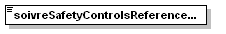
type | restriction of xs:string
properties | SOIVRE – Safety controls  Number of the request for commercial quality controls (SOIVRE).
  content | simple
used by
  element | EquipmentReferences
facets
  minLength | 1
  maxLength | 35
source | <xs:element name="soivreSafetyControlsReferenceNumber">  <xs:simpleType>  <xs:restriction base="xs:string">  <xs:minLength value="1"/>  <xs:maxLength value="35"/>  </xs:restriction>  </xs:simpleType>  </xs:element>
EDIFACT | Group 4, Segment RFF, qualifier Z27, element 1154

element vigilanciaAduaneraReferenceNumber
diagram | 
type | restriction of xs:string
properties | Vigilancia aduanera  Customs declaration number
  content | simple
used by
  element | EquipmentReferences
facets
  minLength | 1
  maxLength | 35
source | <xs:element name="vigilanciaAduaneraReferenceNumber">  <xs:simpleType>  <xs:restriction base="xs:string">  <xs:minLength value="1"/>  <xs:maxLength value="35"/>  </xs:restriction>  </xs:simpleType>  </xs:element>
EDIFACT | Group 4, Segment RFF, qualifier Z28, element 1154

element ARBReferenceNumber
diagram | 
type | restriction of xs:string
properties | ARB – Risk analysis team from Barcelona  Customs declaration number
  content | simple
used by
  element | EquipmentReferences
facets
  minLength | 1
  maxLength | 35
source | <xs:element name="ARBReferenceNumber">  <xs:simpleType>  <xs:restriction base="xs:string">  <xs:minLength value="1"/>  <xs:maxLength value="35"/>  </xs:restriction>  </xs:simpleType>  </xs:element>
EDIFACT | Group 4, Segment RFF, qualifier Z30, element 1154

element otherReferenceNumber
diagram | 
type | restriction of xs:string
properties | Other
  content | simple
used by
  element | EquipmentReferences
facets
  minLength | 1
  maxLength | 35
source | <xs:element name="otherReferenceNumber">  <xs:simpleType>  <xs:restriction base="xs:string">  <xs:minLength value="1"/>  <xs:maxLength value="35"/>  </xs:restriction>  </xs:simpleType>  </xs:element>
EDIFACT | Group 4, Segment RFF, qualifier Z99, element 1154

element earliestDeliveryDate
diagram | 
type | restriction of xs:string
properties | For the request for positioning for inspection and the request for permanence at the inspection area.  Delivery date/time, earliest  Goods have to be positioned the date included in the data element 2380 or after this data.
  content | simple
used by
  element | Equipment
facets
  minLength | 8
  maxLength | 12
annotation
  documentation | Format: CCYYMMDD or CCYYMMDDHHmm
source | <xs:element name="earliestDeliveryDate">  <xs:annotation>  <xs:documentation>Format: CCYYMMDD or CCYYMMDDHHmm</xs:documentation>  </xs:annotation>  <xs:simpleType>  <xs:restriction base="xs:string">  <xs:minLength value="8"/>  <xs:maxLength value="12"/>  </xs:restriction>  </xs:simpleType>  </xs:element>
EDIFACT | Group 4 , Segment DTM, qualifier 64, element 2380

element scheduledForDeliveryDate
diagram | 
type | restriction of xs:string
properties | When the container terminal or the SCPP assign a positioning date  Delivery date/time, scheduled for.
  content | simple
used by
  element | Equipment
facets
  minLength | 8
  maxLength | 12
annotation
  documentation | Format: CCYYMMDD or CCYYMMDDHHmm
source | <xs:element name="scheduledForDeliveryDate">  <xs:annotation>  <xs:documentation>Format: CCYYMMDD or CCYYMMDDHHmm</xs:documentation>  </xs:annotation>  <xs:simpleType>  <xs:restriction base="xs:string">  <xs:minLength value="8"/>  <xs:maxLength value="12"/>  </xs:restriction>  </xs:simpleType>  </xs:element>
EDIFACT | Group 4 , Segment DTM, qualifier 76, element 2380

element GoodsLocation
diagram | 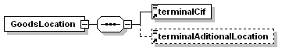
properties | Location of goods  When cargo is containerized, this information is mandatory
  content | complex
children | terminalCif terminalAditionalLocation
used by
  element | Equipment
source | <xs:element name="GoodsLocation">  <xs:complexType>  <xs:sequence>  <xs:element ref="terminalCif"/>  <xs:element ref="terminalAditionalLocation" minOccurs="0"/>  </xs:sequence>  </xs:complexType>  </xs:element>

element terminalCif
diagram | 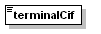
type | restriction of xs:string
properties | For location of goods (code “14” in DE3227), it must be used the CIF/NIF from the terminal of origin (1st scenario) or the terminal where the equipment will be inspected (2nd scenario).
  content | simple
used by
  element | GoodsLocation
facets
  minLength | 1
  maxLength | 25
source | <xs:element name="terminalCif">  <xs:simpleType>  <xs:restriction base="xs:string">  <xs:minLength value="1"/>  <xs:maxLength value="25"/>  </xs:restriction>  </xs:simpleType>  </xs:element>
EDIFACT | Group 4, Segment LOC, qualifier 14, element 3225

element terminalAditionalLocation
diagram | 
type | restriction of xs:string
properties | Special code used when the terminal has more than one location (only with code “14” in DE3227  Mandatory for containerized cargo
  content | simple
used by
  element | GoodsLocation
facets
  minLength | 1
  maxLength | 25
source | <xs:element name="terminalAditionalLocation">  <xs:simpleType>  <xs:restriction base="xs:string">  <xs:minLength value="1"/>  <xs:maxLength value="25"/>  </xs:restriction>  </xs:simpleType>  </xs:element>
EDIFACT | Group 4, Segment LOC, qualifier 14, element 3223

element InspectionLocation
diagram | 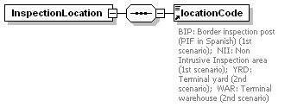
properties | Inspection site  Mandatory for containerized cargo
  content | complex
children | locationCode
used by
  element | Equipment
source | <xs:element name="InspectionLocation">  <xs:complexType>  <xs:sequence>  <xs:element ref="locationCode"/>  </xs:sequence>  </xs:complexType>  </xs:element>

element locationCode
diagram | 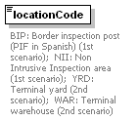
type | restriction of xs:string
properties | For inspection site (code “229” in DE3227), the following temporary codes must be used:  BIP: Border inspection post (PIF in Spanish) (1st scenario)  BRT: Barcelona Reefer Terminal (1st scenario)  NII: Non Intrusive Inspection area (1st scenario)  YRD: Terminal yard (2nd scenario)  WAR: Terminal warehouse (2nd scenario)  PDI: PDI - Import designated points (Puntos designados de importación)(2nd scenario)
  content | simple
used by
  element | InspectionLocation
facets
  enumeration | BIP
  enumeration | BRT
  enumeration | NII
  enumeration | YRD
  enumeration | WAR
  enumeration | PDI
annotation
  documentation | BIP: Border inspection post (PIF in Spanish) (1st scenario); BRT: Barcelona Reefer Terminal (1st scenario); NII: Non Intrusive Inspection area (1st scenario); YRD: Terminal yard (2nd scenario); WAR: Terminal warehouse (2nd scenario); PDI: PDI - Import designated points (Puntos designados de importación)(2nd scenario)
source | <xs:element name="locationCode">  <xs:annotation>  <xs:documentation> BIP: Border inspection post (PIF in Spanish) (1st scenario); BRT: Barcelona Reefer Terminal (1st scenario); NII: Non Intrusive Inspection area (1st scenario); YRD: Terminal yard (2nd scenario); WAR: Terminal warehouse (2nd scenario); PDI: PDI - Import designated points (Puntos designados de importación)(2nd scenario)</xs:documentation>  </xs:annotation>  <xs:simpleType>  <xs:restriction base="xs:string">  <xs:enumeration value="BIP"/>  <xs:enumeration value="BRT"/>  <xs:enumeration value="NII"/>  <xs:enumeration value="YRD"/>  <xs:enumeration value="WAR"/>  <xs:enumeration value="PDI"/>  </xs:restriction>  </xs:simpleType>  </xs:element>
EDIFACT | Group 4, Segment LOC, qualifier 229, element 3225

element GoodsDescription
diagram | 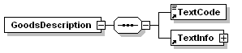
properties | To provide free form or coded text information.  Coded or clear text information related to equipment.  Only one occurrence of this element is required.
  content | complex
children | TextCode TextInfo
used by
  element | Equipment
source | <xs:element name="GoodsDescription">  <xs:complexType>  <xs:sequence>  <xs:element ref="TextCode"/>  <xs:element ref="TextInfo"/>  </xs:sequence>  </xs:complexType>  </xs:element>

element TextCode
diagram | 
type | restriction of xs:string
properties | Use the Combined Nomenclature  Goods identification, coded (código arancelario de la mercancía)
  content | simple
used by
  element | GoodsDescription
facets
  minLength | 1
  maxLength | 17
source | <xs:element name="TextCode">  <xs:simpleType>  <xs:restriction base="xs:string">  <xs:minLength value="1"/>  <xs:maxLength value="17"/>  </xs:restriction>  </xs:simpleType>  </xs:element>
EDIFACT | Group 4, Segment FTX, qualifier AAA, element 4441

element GovernmentalRequirements
diagram | 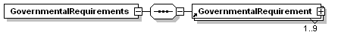
properties | To indicate the requirement for a specific governmental action and/or procedure or which specific procedure is valid for a specific part of the transport. To provide free form or coded text information.  Coded or clear text information related to equipment
  content | complex
children | GovernmentalRequirement
used by
  element | Equipment
source | <xs:element name="GovernmentalRequirements">  <xs:complexType>  <xs:sequence>  <xs:element ref="GovernmentalRequirement" maxOccurs="9"/>  </xs:sequence>  </xs:complexType>  </xs:element>

element GovernmentalRequirement
diagram | 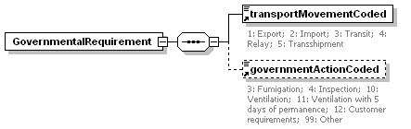
properties
  content | complex
children | transportMovementCoded governmentActionCoded
used by
  element | GovernmentalRequirements
source | <xs:element name="GovernmentalRequirement">  <xs:complexType>  <xs:sequence>  <xs:element ref="transportMovementCoded"/>  <xs:element ref="governmentActionCoded" minOccurs="0"/>  </xs:sequence>  </xs:complexType>  </xs:element>

element transportMovementCoded
diagram | 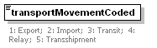
type | restriction of xs:string
properties | TRANSPORT MOVEMENT, CODED  1: Export: Self explanatory.  2: Import: Self explanatory.  5: Transshipment: The cargo is being moved by more than one transport means in succession.
  content | simple
used by
  element | GovernmentalRequirement
facets
  enumeration | 1
  enumeration | 2
  enumeration | 5
annotation
  documentation | 1: Export; 2: Import; 3: Transit; 5: Transshipment
source | <xs:element name="transportMovementCoded">  <xs:annotation>  <xs:documentation>1: Export; 2: Import; 5: Transshipment</xs:documentation>  </xs:annotation>  <xs:simpleType>  <xs:restriction base="xs:string">  <xs:enumeration value="1"/>  <xs:enumeration value="2"/>  <xs:enumeration value="5"/>  </xs:restriction>  </xs:simpleType>  </xs:element>
EDIFACT | Group 4, Segment GOR, element 8323

element governmentActionCoded
diagram | 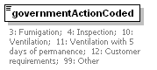
type | restriction of xs:string
properties | Government action, coded  4: Inspection  The cargo has been or will be inspected.  12: Customer requirements  The action has been requested by the customer.  99: Other
  content | simple
used by
  element | GovernmentalRequirement
facets
  enumeration | 4
  enumeration | 12
  enumeration | 99
annotation
  documentation | 4: Inspection; 12: Customer requirements; 99: Other
source | <xs:element name="governmentActionCoded">  <xs:annotation>  <xs:documentation>4: Inspection; 12: Customer requirements; 99: Other</xs:documentation>  </xs:annotation>  <xs:simpleType>  <xs:restriction base="xs:string">  <xs:enumeration value="4"/>  <xs:enumeration value="12"/>  <xs:enumeration value="99"/>  </xs:restriction>  </xs:simpleType>  </xs:element>
EDIFACT | Group 4, Segment GOR, element 9417

element HandlingInstructions
diagram | 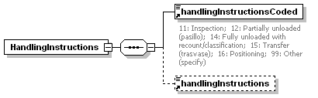
properties | To specify handling and where necessary, notify hazards.  This element is to be used once only, to nominate a specific handling or service instruction for a container or group of containers.  Only one instruction would be indicated. If different services request different operations, it will be necessary to take the most restrictive.
  content | complex
children | handlingInstructionsCoded handlingInstructions
used by
  element | Equipment
source | <xs:element name="HandlingInstructions">  <xs:complexType>  <xs:sequence>  <xs:element ref="handlingInstructionsCoded"/>  <xs:element ref="handlingInstructions" minOccurs="0"/>  </xs:sequence>  </xs:complexType>  </xs:element>

element handlingInstructionsCoded
diagram | 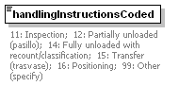
type | restriction of xs:string
properties | Handling instructions, coded  Requested operation:  11: Inspection  12: Partially unloaded (pasillo)  14: Fully unloaded with recount/classification  15: Transfer (trasvase)  16: Positioning  17: Fumigation. The cargo has been or will be fumigated.  18: Ventilation. The cargo has been or will be ventilated.  19: Ventilation with 5 days of permanence. The cargo has been or will be ventilated.  99: Other (specify)
  content | simple
used by
  element | HandlingInstructions
facets
  enumeration | 11
  enumeration | 12
  enumeration | 14
  enumeration | 15
  enumeration | 16
  enumeration | 17
  enumeration | 18
  enumeration | 19
  enumeration | 99
annotation
  documentation | 11: Inspection; 12: Partially unloaded (pasillo); 14: Fully unloaded with recount/classification; 15: Transfer (trasvase); 16: Positioning; 17: Fumigation; 18: Ventilation. The cargo has been or will be ventilated; 19: Ventilation with 5 days of permanence; 99: Other (specify)
source | <xs:element name="handlingInstructionsCoded">  <xs:annotation>  <xs:documentation>11: Inspection; 12: Partially unloaded (pasillo); 14: Fully unloaded with recount/classification; 15: Transfer (trasvase); 16: Positioning; 17: Fumigation; 18: Ventilation. The cargo has been or will be ventilated; 19: Ventilation with 5 days of permanence; 99: Other (specify)</xs:documentation>  </xs:annotation>  <xs:simpleType>  <xs:restriction base="xs:string">  <xs:enumeration value="11"/>  <xs:enumeration value="12"/>  <xs:enumeration value="14"/>  <xs:enumeration value="15"/>  <xs:enumeration value="16"/>  <xs:enumeration value="17"/>  <xs:enumeration value="18"/>  <xs:enumeration value="19"/>  <xs:enumeration value="99"/>  </xs:restriction>  </xs:simpleType>  </xs:element>
EDIFACT | Group 4, Segment HAN, element 4079

element handlingInstructions
diagram | 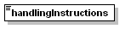
type | restriction of xs:string
properties | If handlingInstructionsCoded is “other”, specify the requested operation
  content | simple
used by
  element | HandlingInstructions
facets
  minLength | 1
  maxLength | 70
source | <xs:element name="handlingInstructions">  <xs:simpleType>  <xs:restriction base="xs:string">  <xs:minLength value="1"/>  <xs:maxLength value="70"/>  </xs:restriction>  </xs:simpleType>  </xs:element>
EDIFACT | Group 4, Segment HAN, element 4078

element grossWeight
diagram | 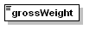
type | restriction of xs:string
properties | To specify physical measurements, including dimension tolerances, weights and counts.  Gross Weight of the goods to be inspected.
  content | simple
used by
  element | Equipment
facets
  minLength | 1
  maxLength | 18
source | <xs:element name="grossWeight">  <xs:simpleType>  <xs:restriction base="xs:string">  <xs:minLength value="1"/>  <xs:maxLength value="18"/>  </xs:restriction>  </xs:simpleType>  </xs:element>
EDIFACT | Group 4, Segment MEA, element 6314

element totalGrossWeight
diagram | 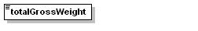
type | restriction of xs:string
properties | Total gross Weight of the goods in the container.  For LCL containers, this element is required.
  content | simple
used by
  element | Equipment
facets
  minLength | 1
  maxLength | 18
source | <xs:element name="totalGrossWeight">  <xs:simpleType>  <xs:restriction base="xs:string">  <xs:minLength value="1"/>  <xs:maxLength value="18"/>  </xs:restriction>  </xs:simpleType>  </xs:element>
EDIFACT | Group 4, Segment MEA, element 6314

element Vessel
diagram | 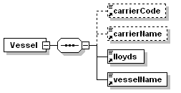
properties | A Group of segments to indicate details of inland movement of equipment.  The Vessel at this level is used to specify transport arrangements beyond the location from which the equipment is released.  It will be mandatory for import and containerized cargo.  To specify the transport details such as mode of transport, means of transport, its conveyance reference number and the identification of the means of transport.
  content | complex
children | carrierCode carrierName lloyds vesselName
used by
  element | Equipment
source | <xs:element name="Vessel">  <xs:complexType>  <xs:sequence>  <xs:element ref="carrierCode" minOccurs="0"/>  <xs:element ref="carrierName" minOccurs="0"/>  <xs:element ref="lloyds"/>  <xs:element ref="vesselName"/>  </xs:sequence>  </xs:complexType>  </xs:element>

element carrierCode
diagram | 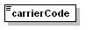
type | restriction of xs:string
properties | Carrier code
  content | simple
used by
  element | Vessel
facets
  minLength | 1
  maxLength | 17
source | <xs:element name="carrierCode">  <xs:simpleType>  <xs:restriction base="xs:string">  <xs:minLength value="1"/>  <xs:maxLength value="17"/>  </xs:restriction>  </xs:simpleType>  </xs:element>
EDIFACT | Group 5, Segment TDT, element 3127

element carrierName
diagram | 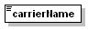
type | restriction of xs:string
properties | Carrier name (free text)
  content | simple
used by
  element | Vessel
facets
  minLength | 1
  maxLength | 35
source | <xs:element name="carrierName">  <xs:simpleType>  <xs:restriction base="xs:string">  <xs:minLength value="1"/>  <xs:maxLength value="35"/>  </xs:restriction>  </xs:simpleType>  </xs:element>
EDIFACT | Group 5, Segment TDT, element 3128

element lloyds
diagram | 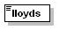
type | restriction of xs:string
properties | Lloyd’s Number
  content | simple
used by
  element | Vessel
facets
  minLength | 1
  maxLength | 9
source | <xs:element name="lloyds">  <xs:simpleType>  <xs:restriction base="xs:string">  <xs:minLength value="1"/>  <xs:maxLength value="9"/>  </xs:restriction>  </xs:simpleType>  </xs:element>
EDIFACT | Group 5, Segment TDT, element 8213

element vesselName
diagram | 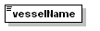
type | restriction of xs:string
properties | Vessel name (free text)
  content | simple
used by
  element | Vessel
facets
  minLength | 1
  maxLength | 35
source | <xs:element name="vesselName">  <xs:simpleType>  <xs:restriction base="xs:string">  <xs:minLength value="1"/>  <xs:maxLength value="35"/>  </xs:restriction>  </xs:simpleType>  </xs:element>
EDIFACT | Group 5, Segment TDT, element 8212

element DangerousGoods
diagram | 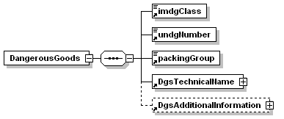
properties | A Group of segments to indicate the dangerous goods details related to the goods item.  To specify the dangerous goods details related to the goods item.  When dangerous goods are stored in the container, an occurrence of this group will be used: When there are several dangerous goods in the same container, the most dangerous one must be declared.
  content | complex
children | imdgClass undgNumber packingGroup DgsTechnicalName DgsAdditionalInformation
used by
  element | Equipment
source | <xs:element name="DangerousGoods">  <xs:complexType>  <xs:sequence>  <xs:element ref="imdgClass"/>  <xs:element ref="undgNumber"/>  <xs:element ref="packingGroup"/>  <xs:element ref="DgsTechnicalName"/>  <xs:element ref="DgsAdditionalInformation" minOccurs="0"/>  </xs:sequence>  </xs:complexType>  </xs:element>

element imdgClass
diagram | 
type | restriction of xs:string
properties | IMDG Class Number
  content | simple
used by
  element | DangerousGoods
facets
  minLength | 1
  maxLength | 7
source | <xs:element name="imdgClass">  <xs:simpleType>  <xs:restriction base="xs:string">  <xs:minLength value="1"/>  <xs:maxLength value="7"/>  </xs:restriction>  </xs:simpleType>  </xs:element>
EDIFACT | Group 9, Segment DGS, element 8351

element undgNumber
diagram | 
type | restriction of xs:string
properties | UNDG number
  content | simple
used by
  element | DangerousGoods
facets
  minLength | 1
  maxLength | 4
source | <xs:element name="undgNumber">  <xs:simpleType>  <xs:restriction base="xs:string">  <xs:minLength value="1"/>  <xs:maxLength value="4"/>  </xs:restriction>  </xs:simpleType>  </xs:element>
EDIFACT | Group 9, Segment DGS, element 7124

element packingGroup
diagram | 
type | restriction of xs:string
properties | Packing group
  content | simple
used by
  element | DangerousGoods
facets
  minLength | 1
  maxLength | 3
source | <xs:element name="packingGroup">  <xs:simpleType>  <xs:restriction base="xs:string">  <xs:minLength value="1"/>  <xs:maxLength value="3"/>  </xs:restriction>  </xs:simpleType>  </xs:element>
EDIFACT | Group 9, Segment DGS, element 8339

element DgsTechnicalName
diagram | 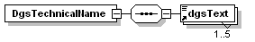
properties | Dangerous goods technical name  To provide free form or coded text information.  To specify the textual information of the dangerous goods, such as proper shipping name and additional dangerous goods information.
  content | complex
children | dgsText
used by
  element | DangerousGoods
source | <xs:element name="DgsTechnicalName">  <xs:complexType>  <xs:sequence>  <xs:element ref="dgsText" maxOccurs="5"/>  </xs:sequence>  </xs:complexType>  </xs:element>
EDIFACT | Group 9, Segment FTX, qualifier AAD, element 4440

element dgsText
diagram | 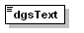
type | restriction of xs:string
properties
  content | simple
used by
  elements | DgsTechnicalName DgsAdditionalInformation
facets
  minLength | 1
  maxLength | 26
source | <xs:element name="dgsText">  <xs:simpleType>  <xs:restriction base="xs:string">  <xs:minLength value="1"/>  <xs:maxLength value="26"/>  </xs:restriction>  </xs:simpleType>  </xs:element>

element DgsAdditionalInformation
diagram | 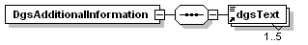
properties | Dangerous goods additional information  To provide free form or coded text information.  To specify the textual information of the dangerous goods, such as proper shipping name and additional dangerous goods information.
  content | complex
children | dgsText
used by
  element | DangerousGoods
source | <xs:element name="DgsAdditionalInformation">  <xs:complexType>  <xs:sequence>  <xs:element ref="dgsText" maxOccurs="5"/>  </xs:sequence>  </xs:complexType>  </xs:element>
EDIFACT | Group 9, Segment FTX, qualifier AAC, element 4440

element Temperature
diagram | 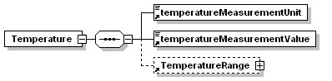
properties | A segment group to identify transport related temperature settings.  When controlled temperature goods are stored in the container, an occurrence of this group has to be used.  A segment to specify the type of transport related temperature such as storage, transport or operating temperature and also to optionally specify a single value temperature setting.
  content | complex
children | temperatureMeasurementUnit temperatureMeasurementValue TemperatureRange
used by
  element | Equipment
source | <xs:element name="Temperature">  <xs:complexType>  <xs:sequence>  <xs:element ref="temperatureMeasurementUnit"/>  <xs:element ref="temperatureMeasurementValue"/>  <xs:element ref="TemperatureRange" minOccurs="0"/>  </xs:sequence>  </xs:complexType>  </xs:element>

element temperatureMeasurementUnit
diagram | 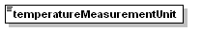
type | restriction of xs:string
properties | Measure Unit qualifier  CEL: Celsius  FAH: Degree Fahrenheit
  content | simple
used by
  element | Temperature
facets
  enumeration | CEL
  enumeration | FAH
source | <xs:element name="temperatureMeasurementUnit">  <xs:simpleType>  <xs:restriction base="xs:string">  <xs:enumeration value="CEL"/>  <xs:enumeration value="FAH"/>  </xs:restriction>  </xs:simpleType>  </xs:element>
EDIFACT | Group 11, Segment TMP, element 6411

element temperatureMeasurementValue
diagram | 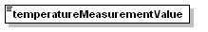
type | restriction of xs:string
properties | Temperature setting of the container.
  content | simple
used by
  element | Temperature
facets
  minLength | 1
  maxLength | 15
source | <xs:element name="temperatureMeasurementValue">  <xs:simpleType>  <xs:restriction base="xs:string">  <xs:minLength value="1"/>  <xs:maxLength value="15"/>  </xs:restriction>  </xs:simpleType>  </xs:element>
EDIFACT | Group 11, Segment TMP, element 6246

element TemperatureRange
diagram | 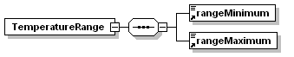
properties | The RNG segment may be used if a range of temperatures is to be specified. It should always be used in conjunction with the preceding TMP segment.
  content | complex
children | rangeMinimum rangeMaximum
used by
  element | Temperature
source | <xs:element name="TemperatureRange">  <xs:complexType>  <xs:sequence>  <xs:element ref="rangeMinimum"/>  <xs:element ref="rangeMaximum"/>  </xs:sequence>  </xs:complexType>  </xs:element>

element rangeMinimum
diagram | 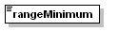
type | restriction of xs:string
properties | Lowest temperature
  content | simple
used by
  element | TemperatureRange
facets
  minLength | 1
  maxLength | 15
source | <xs:element name="rangeMinimum">  <xs:simpleType>  <xs:restriction base="xs:string">  <xs:minLength value="1"/>  <xs:maxLength value="15"/>  </xs:restriction>  </xs:simpleType>  </xs:element>
EDIFACT | Group 11, Segment RNG, element 6162

element rangeMaximum
diagram | 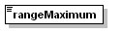
type | restriction of xs:string
properties | Highest temperature
  content | simple
used by
  element | TemperatureRange
facets
  minLength | 1
  maxLength | 15
source | <xs:element name="rangeMaximum">  <xs:simpleType>  <xs:restriction base="xs:string">  <xs:minLength value="1"/>  <xs:maxLength value="15"/>  </xs:restriction>  </xs:simpleType>  </xs:element>
EDIFACT | Group 11, Segment RNG, element 6152

SCHEMA

Shema of the message

<xs:schema xmlns:xs="http://www.w3.org/2001/XMLSchema">
<xs:element name="COHAOR">
<xs:complexType>
<xs:sequence>
<xs:element ref="MessageHeader"/>
<xs:element ref="GeneralRemarks" minOccurs="0"/>
<xs:element ref="Comment" minOccurs="0"/>
<xs:element ref="ChangeInformation" minOccurs="0"/>
<xs:element ref="PackingMarkingInformation"/>
<xs:element ref="References" minOccurs="0"/>
<xs:element ref="MessageSender"/>
<xs:element ref="Consignee" minOccurs="0"/>
<xs:element ref="Invoicee" minOccurs="0"/>
<xs:element ref="Equipment"/>
</xs:sequence>
</xs:complexType>
</xs:element>
<xs:element name="MessageHeader">
<xs:complexType>
<xs:sequence>
<xs:element ref="messageVersion"/>
<xs:element ref="messageReference"/>
<xs:element ref="messageCode"/>
<xs:element ref="messageFunction"/>
<xs:element ref="messageDate"/>
<xs:element ref="documentVersion"/>
<xs:element ref="senderId"/>
<xs:element ref="receiverId"/>
</xs:sequence>
</xs:complexType>
</xs:element>
<xs:element name="messageVersion">
<xs:simpleType>
<xs:restriction base="xs:string">
<xs:enumeration value="D00B"/>
</xs:restriction>
</xs:simpleType>
</xs:element>
<xs:element name="messageReference">
<xs:simpleType>
<xs:restriction base="xs:string">
<xs:minLength value="1"/>
<xs:maxLength value="14"/>
</xs:restriction>
</xs:simpleType>
</xs:element>
<xs:element name="messageCode">
<xs:annotation>
<xs:documentation>292: Inspection request ; 844: Express Inspection Request; 845: Inspection instruction; 846: Communication about a previous scheduled inspection; 847: Request for permanence at the inspection area</xs:documentation>
</xs:annotation>
<xs:simpleType>
<xs:restriction base="xs:string">
<xs:enumeration value="292"/>
<xs:enumeration value="844"/>
<xs:enumeration value="845"/>
<xs:enumeration value="846"/>
<xs:enumeration value="847"/>
</xs:restriction>
</xs:simpleType>
</xs:element>
<xs:element name="messageFunction">
<xs:annotation>
<xs:documentation>9: Original ; 1: Cancellation; 27: Not accepted; 29: Accepted without amendment; 34: Accepted with amendment</xs:documentation>
</xs:annotation>
<xs:simpleType>
<xs:restriction base="xs:string">
<xs:enumeration value="1"/>
<xs:enumeration value="9"/>
<xs:enumeration value="27"/>
<xs:enumeration value="29"/>
<xs:enumeration value="34"/>
</xs:restriction>
</xs:simpleType>
</xs:element>
<xs:element name="messageDate">
<xs:annotation>
<xs:documentation>Format: CCYYMMDDHHMM</xs:documentation>
</xs:annotation>
<xs:simpleType>
<xs:restriction base="xs:string">
<xs:minLength value="12"/>
<xs:maxLength value="12"/>
</xs:restriction>
</xs:simpleType>
</xs:element>
<xs:element name="documentVersion">
<xs:simpleType>
<xs:restriction base="xs:string">
<xs:minLength value="1"/>
<xs:maxLength value="35"/>
</xs:restriction>
</xs:simpleType>
</xs:element>
<xs:element name="senderId">
<xs:simpleType>
<xs:restriction base="xs:string">
<xs:minLength value="1"/>
<xs:maxLength value="35"/>
</xs:restriction>
</xs:simpleType>
</xs:element>
<xs:element name="receiverId">
<xs:simpleType>
<xs:restriction base="xs:string">
<xs:minLength value="1"/>
<xs:maxLength value="35"/>
</xs:restriction>
</xs:simpleType>
</xs:element>
<xs:element name="GeneralRemarks">
<xs:complexType>
<xs:sequence>
<xs:element ref="generalRemarksTextCode" minOccurs="0"/>
<xs:element ref="TextInfo" minOccurs="0"/>
</xs:sequence>
</xs:complexType>
</xs:element>
<xs:element name="generalRemarksTextCode">
<xs:simpleType>
<xs:restriction base="xs:string">
<xs:enumeration value="PX"/>
</xs:restriction>
</xs:simpleType>
</xs:element>
<xs:element name="TextInfo">
<xs:complexType>
<xs:sequence>
<xs:element ref="text" maxOccurs="5"/>
</xs:sequence>
</xs:complexType>
</xs:element>
<xs:element name="text">
<xs:simpleType>
<xs:restriction base="xs:string">
<xs:minLength value="1"/>
<xs:maxLength value="512"/>
</xs:restriction>
</xs:simpleType>
</xs:element>
<xs:element name="Comment">
<xs:complexType>
<xs:sequence>
<xs:element ref="TextInfo" minOccurs="0"/>
</xs:sequence>
</xs:complexType>
</xs:element>
<xs:element name="ChangeInformation">
<xs:complexType>
<xs:sequence>
<xs:element ref="changeInformationTextCode" minOccurs="0"/>
<xs:element ref="TextInfo" minOccurs="0"/>
</xs:sequence>
</xs:complexType>
</xs:element>
<xs:element name="changeInformationTextCode">
<xs:annotation>
<xs:documentation>C1: Message level information changed; C2: Message level information added; C3: Message level information deleted; C4: Container information changed; C5: Container(s) added; C6: Container(s) deleted</xs:documentation>
</xs:annotation>
<xs:simpleType>
<xs:restriction base="xs:string">
<xs:enumeration value="C1"/>
<xs:enumeration value="C2"/>
<xs:enumeration value="C3"/>
<xs:enumeration value="C4"/>
<xs:enumeration value="C5"/>
<xs:enumeration value="C6"/>
</xs:restriction>
</xs:simpleType>
</xs:element>
<xs:element name="PackingMarkingInformation">
<xs:complexType>
<xs:sequence>
<xs:element ref="PackingCode"/>
<xs:element ref="NumberOfPackages" minOccurs="0"/>
<xs:element ref="TotalNumberOfPackages" minOccurs="0"/>
</xs:sequence>
</xs:complexType>
</xs:element>
<xs:element name="PackingCode">
<xs:simpleType>
<xs:restriction base="xs:string">
<xs:minLength value="1"/>
<xs:maxLength value="17"/>
</xs:restriction>
</xs:simpleType>
</xs:element>
<xs:element name="NumberOfPackages">
<xs:simpleType>
<xs:restriction base="xs:string">
<xs:minLength value="1"/>
<xs:maxLength value="17"/>
</xs:restriction>
</xs:simpleType>
</xs:element>
<xs:element name="TotalNumberOfPackages">
<xs:simpleType>
<xs:restriction base="xs:string">
<xs:minLength value="1"/>
<xs:maxLength value="17"/>
</xs:restriction>
</xs:simpleType>
</xs:element>
<xs:element name="References">
<xs:complexType>
<xs:sequence>
<xs:element ref="PreviousMessageReference" minOccurs="0"/>
<xs:element ref="FreightForwardersReference" minOccurs="0"/>
<xs:element ref="GroupReference" minOccurs="0"/>
</xs:sequence>
</xs:complexType>
</xs:element>
<xs:element name="PreviousMessageReference">
<xs:complexType>
<xs:sequence>
<xs:element ref="previousMessageReferenceNumber"/>
</xs:sequence>
</xs:complexType>
</xs:element>
<xs:element name="previousMessageReferenceNumber">
<xs:simpleType>
<xs:restriction base="xs:string">
<xs:minLength value="1"/>
<xs:maxLength value="35"/>
</xs:restriction>
</xs:simpleType>
</xs:element>
<xs:element name="FreightForwardersReference">
<xs:complexType>
<xs:sequence>
<xs:element ref="freightForwardersReferenceNumber"/>
</xs:sequence>
</xs:complexType>
</xs:element>
<xs:element name="freightForwardersReferenceNumber">
<xs:simpleType>
<xs:restriction base="xs:string">
<xs:minLength value="1"/>
<xs:maxLength value="35"/>
</xs:restriction>
</xs:simpleType>
</xs:element>
<xs:element name="GroupReference">
<xs:complexType>
<xs:sequence>
<xs:element ref="groupReferenceNumber"/>
<xs:element ref="groupReferenceNumberOfContainers" minOccurs="0"/>
</xs:sequence>
</xs:complexType>
</xs:element>
<xs:element name="groupReferenceNumber">
<xs:simpleType>
<xs:restriction base="xs:string">
<xs:minLength value="1"/>
<xs:maxLength value="35"/>
</xs:restriction>
</xs:simpleType>
</xs:element>
<xs:element name="groupReferenceNumberOfContainers">
<xs:simpleType>
<xs:restriction base="xs:string">
<xs:minLength value="1"/>
<xs:maxLength value="6"/>
</xs:restriction>
</xs:simpleType>
</xs:element>
<xs:element name="MessageSender">
<xs:complexType>
<xs:sequence>
<xs:element ref="partyIdentificationNumber"/>
<xs:element ref="partyName" maxOccurs="5"/>
<xs:element ref="partyAddress" minOccurs="0" maxOccurs="5"/>
<xs:element ref="partyStreet" minOccurs="0" maxOccurs="3"/>
<xs:element ref="partyCity" minOccurs="0"/>
<xs:element ref="postCode" minOccurs="0"/>
<xs:element ref="partyCountry" minOccurs="0"/>
</xs:sequence>
</xs:complexType>
</xs:element>
<xs:element name="partyIdentificationNumber">
<xs:simpleType>
<xs:restriction base="xs:string">
<xs:minLength value="1"/>
<xs:maxLength value="35"/>
</xs:restriction>
</xs:simpleType>
</xs:element>
<xs:element name="partyName">
<xs:simpleType>
<xs:restriction base="xs:string">
<xs:minLength value="1"/>
<xs:maxLength value="35"/>
</xs:restriction>
</xs:simpleType>
</xs:element>
<xs:element name="partyAddress">
<xs:simpleType>
<xs:restriction base="xs:string">
<xs:minLength value="1"/>
<xs:maxLength value="35"/>
</xs:restriction>
</xs:simpleType>
</xs:element>
<xs:element name="partyStreet">
<xs:simpleType>
<xs:restriction base="xs:string">
<xs:minLength value="1"/>
<xs:maxLength value="35"/>
</xs:restriction>
</xs:simpleType>
</xs:element>
<xs:element name="partyCity">
<xs:simpleType>
<xs:restriction base="xs:string">
<xs:minLength value="1"/>
<xs:maxLength value="35"/>
</xs:restriction>
</xs:simpleType>
</xs:element>
<xs:element name="postCode">
<xs:simpleType>
<xs:restriction base="xs:string">
<xs:minLength value="1"/>
<xs:maxLength value="9"/>
</xs:restriction>
</xs:simpleType>
</xs:element>
<xs:element name="partyCountry">
<xs:simpleType>
<xs:restriction base="xs:string">
<xs:minLength value="1"/>
<xs:maxLength value="3"/>
</xs:restriction>
</xs:simpleType>
</xs:element>
<xs:element name="Consignee">
<xs:complexType>
<xs:sequence>
<xs:element ref="partyIdentificationNumber"/>
<xs:element ref="partyName" maxOccurs="5"/>
<xs:element ref="partyAddress" minOccurs="0" maxOccurs="5"/>
<xs:element ref="partyStreet" minOccurs="0" maxOccurs="3"/>
<xs:element ref="partyCity" minOccurs="0"/>
<xs:element ref="postCode" minOccurs="0"/>
<xs:element ref="partyCountry" minOccurs="0"/>
</xs:sequence>
</xs:complexType>
</xs:element>
<xs:element name="Invoicee">
<xs:complexType>
<xs:sequence>
<xs:element ref="partyIdentificationNumber" minOccurs="0"/>
<xs:element ref="partyName" minOccurs="0" maxOccurs="5"/>
<xs:element ref="partyAddress" minOccurs="0" maxOccurs="5"/>
<xs:element ref="partyStreet" minOccurs="0" maxOccurs="3"/>
<xs:element ref="partyCity" minOccurs="0"/>
<xs:element ref="postCode" minOccurs="0"/>
<xs:element ref="partyCountry" minOccurs="0"/>
</xs:sequence>
</xs:complexType>
</xs:element>
<xs:element name="Equipment">
<xs:complexType>
<xs:sequence>
<xs:element ref="equipmentIdentificationNumber"/>
<xs:element ref="codeListQualifier" minOccurs="0"/>
<xs:element ref="equipmentType" minOccurs="0"/>
<xs:element ref="EquipmentReferences"/>
<xs:element ref="earliestDeliveryDate" minOccurs="0"/>
<xs:element ref="scheduledForDeliveryDate" minOccurs="0"/>
<xs:element ref="GoodsLocation" minOccurs="0"/>
<xs:element ref="InspectionLocation"/>
<xs:element ref="GoodsDescription"/>
<xs:element ref="GovernmentalRequirements"/>
<xs:element ref="HandlingInstructions"/>
<xs:element ref="grossWeight" minOccurs="0"/>
<xs:element ref="totalGrossWeight" minOccurs="0"/>
<xs:element ref="Vessel" minOccurs="0"/>
<xs:element ref="DangerousGoods" minOccurs="0"/>
<xs:element ref="Temperature" minOccurs="0"/>
</xs:sequence>
</xs:complexType>
</xs:element>
<xs:element name="equipmentIdentificationNumber">
<xs:simpleType>
<xs:restriction base="xs:string">
<xs:minLength value="1"/>
<xs:maxLength value="17"/>
</xs:restriction>
</xs:simpleType>
</xs:element>
<xs:element name="codeListQualifier">
<xs:simpleType>
<xs:restriction base="xs:string">
<xs:enumeration value="55"/>
</xs:restriction>
</xs:simpleType>
</xs:element>
<xs:element name="equipmentType">
<xs:simpleType>
<xs:restriction base="xs:string">
<xs:minLength value="1"/>
<xs:maxLength value="10"/>
</xs:restriction>
</xs:simpleType>
</xs:element>
<xs:element name="EquipmentReferences">
<xs:complexType>
<xs:sequence>
<xs:element ref="shipsStayReferenceNumber" minOccurs="0"/>
<xs:element ref="customsDeclarationReferenceNumber" minOccurs="0"/>
<xs:element ref="sanidadVegetalReferenceNumber" minOccurs="0"/>
<xs:element ref="sanidadAnimalReferenceNumber" minOccurs="0"/>
<xs:element ref="sanidadExteriorAnimalReferenceNumber" minOccurs="0"/>
<xs:element ref="sanidadExteriorVegetalReferenceNumber" minOccurs="0"/>
<xs:element ref="farmaciaReferenceNumber" minOccurs="0"/>
<xs:element ref="soivreQualityControlReferenceNumber" minOccurs="0"/>
<xs:element ref="soivreCitesReferenceNumber" minOccurs="0"/>
<xs:element ref="soivreSafetyControlsReferenceNumber" minOccurs="0"/>
<xs:element ref="vigilanciaAduaneraReferenceNumber" minOccurs="0"/>
<xs:element ref="ARBReferenceNumber" minOccurs="0"/>
<xs:element ref="otherReferenceNumber" minOccurs="0"/>
</xs:sequence>
</xs:complexType>
</xs:element>
<xs:element name="shipsStayReferenceNumber">
<xs:simpleType>
<xs:restriction base="xs:string">
<xs:minLength value="1"/>
<xs:maxLength value="35"/>
</xs:restriction>
</xs:simpleType>
</xs:element>
<xs:element name="customsDeclarationReferenceNumber">
<xs:simpleType>
<xs:restriction base="xs:string">
<xs:minLength value="1"/>
<xs:maxLength value="35"/>
</xs:restriction>
</xs:simpleType>
</xs:element>
<xs:element name="sanidadVegetalReferenceNumber">
<xs:simpleType>
<xs:restriction base="xs:string">
<xs:minLength value="1"/>
<xs:maxLength value="35"/>
</xs:restriction>
</xs:simpleType>
</xs:element>
<xs:element name="sanidadAnimalReferenceNumber">
<xs:simpleType>
<xs:restriction base="xs:string">
<xs:minLength value="1"/>
<xs:maxLength value="35"/>
</xs:restriction>
</xs:simpleType>
</xs:element>
<xs:element name="sanidadExteriorAnimalReferenceNumber">
<xs:simpleType>
<xs:restriction base="xs:string">
<xs:minLength value="1"/>
<xs:maxLength value="35"/>
</xs:restriction>
</xs:simpleType>
</xs:element>
<xs:element name="sanidadExteriorVegetalReferenceNumber">
<xs:simpleType>
<xs:restriction base="xs:string">
<xs:minLength value="1"/>
<xs:maxLength value="35"/>
</xs:restriction>
</xs:simpleType>
</xs:element>
<xs:element name="farmaciaReferenceNumber">
<xs:simpleType>
<xs:restriction base="xs:string">
<xs:minLength value="1"/>
<xs:maxLength value="35"/>
</xs:restriction>
</xs:simpleType>
</xs:element>
<xs:element name="soivreQualityControlReferenceNumber">
<xs:simpleType>
<xs:restriction base="xs:string">
<xs:minLength value="1"/>
<xs:maxLength value="35"/>
</xs:restriction>
</xs:simpleType>
</xs:element>
<xs:element name="soivreCitesReferenceNumber">
<xs:simpleType>
<xs:restriction base="xs:string">
<xs:minLength value="1"/>
<xs:maxLength value="35"/>
</xs:restriction>
</xs:simpleType>
</xs:element>
<xs:element name="soivreSafetyControlsReferenceNumber">
<xs:simpleType>
<xs:restriction base="xs:string">
<xs:minLength value="1"/>
<xs:maxLength value="35"/>
</xs:restriction>
</xs:simpleType>
</xs:element>
<xs:element name="vigilanciaAduaneraReferenceNumber">
<xs:simpleType>
<xs:restriction base="xs:string">
<xs:minLength value="1"/>
<xs:maxLength value="35"/>
</xs:restriction>
</xs:simpleType>
</xs:element>
<xs:element name="ARBReferenceNumber">
<xs:simpleType>
<xs:restriction base="xs:string">
<xs:minLength value="1"/>
<xs:maxLength value="35"/>
</xs:restriction>
</xs:simpleType>
</xs:element>
<xs:element name="otherReferenceNumber">
<xs:simpleType>
<xs:restriction base="xs:string">
<xs:minLength value="1"/>
<xs:maxLength value="35"/>
</xs:restriction>
</xs:simpleType>
</xs:element>
<xs:element name="earliestDeliveryDate">
<xs:annotation>
<xs:documentation>Formats: CCYYMMDD o CCYYMMDDHHMM</xs:documentation>
</xs:annotation>
<xs:simpleType>
<xs:restriction base="xs:string">
<xs:minLength value="8"/>
<xs:maxLength value="12"/>
</xs:restriction>
</xs:simpleType>
</xs:element>
<xs:element name="scheduledForDeliveryDate">
<xs:annotation>
<xs:documentation>Formats: CCYYMMDD o CCYYMMDDHHMM</xs:documentation>
</xs:annotation>
<xs:simpleType>
<xs:restriction base="xs:string">
<xs:minLength value="8"/>
<xs:maxLength value="12"/>
</xs:restriction>
</xs:simpleType>
</xs:element>
<xs:element name="GoodsLocation">
<xs:complexType>
<xs:sequence>
<xs:element ref="terminalCif"/>
<xs:element ref="terminalAditionalLocation" minOccurs="0"/>
</xs:sequence>
</xs:complexType>
</xs:element>
<xs:element name="InspectionLocation">
<xs:complexType>
<xs:sequence>
<xs:element ref="locationCode"/>
</xs:sequence>
</xs:complexType>
</xs:element>
<xs:element name="terminalCif">
<xs:simpleType>
<xs:restriction base="xs:string">
<xs:minLength value="1"/>
<xs:maxLength value="25"/>
</xs:restriction>
</xs:simpleType>
</xs:element>
<xs:element name="terminalAditionalLocation">
<xs:simpleType>
<xs:restriction base="xs:string">
<xs:minLength value="1"/>
<xs:maxLength value="25"/>
</xs:restriction>
</xs:simpleType>
</xs:element>
<xs:element name="locationCode">
<xs:annotation>
<xs:documentation>BIP: Border inspection post (PIF in Spanish) (1st scenario); BRT: Barcelona Reefer Terminal (1st scenario); NII: Non Intrusive Inspection area (1st scenario); YRD: Terminal yard (2nd scenario); WAR: Terminal warehouse (2nd scenario); PDI: PDI - Import designated points (Puntos designados de importaciÃ³n)(2nd scenario)</xs:documentation>
</xs:annotation>
<xs:simpleType>
<xs:restriction base="xs:string">
<xs:enumeration value="BIP"/>
<xs:enumeration value="BRT"/>
<xs:enumeration value="NII"/>
<xs:enumeration value="YRD"/>
<xs:enumeration value="WAR"/>
<xs:enumeration value="PDI"/>
</xs:restriction>
</xs:simpleType>
</xs:element>
<xs:element name="GoodsDescription">
<xs:complexType>
<xs:sequence>
<xs:element ref="TextCode"/>
<xs:element ref="TextInfo"/>
</xs:sequence>
</xs:complexType>
</xs:element>
<xs:element name="TextCode">
<xs:simpleType>
<xs:restriction base="xs:string">
<xs:minLength value="1"/>
<xs:maxLength value="17"/>
</xs:restriction>
</xs:simpleType>
</xs:element>
<xs:element name="GovernmentalRequirements">
<xs:complexType>
<xs:sequence>
<xs:element ref="GovernmentalRequirement" maxOccurs="9"/>
</xs:sequence>
</xs:complexType>
</xs:element>
<xs:element name="GovernmentalRequirement">
<xs:complexType>
<xs:sequence>
<xs:element ref="transportMovementCoded"/>
<xs:element ref="governmentActionCoded" minOccurs="0"/>
</xs:sequence>
</xs:complexType>
</xs:element>
<xs:element name="transportMovementCoded">
<xs:annotation>
<xs:documentation>1: Export; 2: Import; 3: Transit; 5: Transshipment</xs:documentation>
</xs:annotation>
<xs:simpleType>
<xs:restriction base="xs:string">
<xs:enumeration value="1"/>
<xs:enumeration value="2"/>
<xs:enumeration value="3"/>
<xs:enumeration value="5"/>
</xs:restriction>
</xs:simpleType>
</xs:element>
<xs:element name="governmentActionCoded">
<xs:annotation>
<xs:documentation>4: Inspection; 12: Customer requirements; 99: Other</xs:documentation>
</xs:annotation>
<xs:simpleType>
<xs:restriction base="xs:string">
<xs:enumeration value="4"/>
<xs:enumeration value="12"/>
<xs:enumeration value="99"/>
</xs:restriction>
</xs:simpleType>
</xs:element>
<xs:element name="HandlingInstructions">
<xs:complexType>
<xs:sequence>
<xs:element ref="handlingInstructionsCoded"/>
<xs:element ref="handlingInstructions" minOccurs="0"/>
</xs:sequence>
</xs:complexType>
</xs:element>
<xs:element name="handlingInstructionsCoded">
<xs:annotation>
<xs:documentation>11: Inspection; 12: Partially unloaded (pasillo); 14: Fully unloaded with recount/classification; 15: Transfer (trasvase); 16: Positioning; 17: Fumigation; 18: Ventilation. The cargo has been or will be ventilated; 19: Ventilation with 5 days of permanence; 99: Other (specify)</xs:documentation>
</xs:annotation>
<xs:simpleType>
<xs:restriction base="xs:string">
<xs:enumeration value="11"/>
<xs:enumeration value="12"/>
<xs:enumeration value="14"/>
<xs:enumeration value="15"/>
<xs:enumeration value="16"/>
<xs:enumeration value="17"/>
<xs:enumeration value="18"/>
<xs:enumeration value="19"/>
<xs:enumeration value="99"/>
</xs:restriction>
</xs:simpleType>
</xs:element>
<xs:element name="handlingInstructions">
<xs:simpleType>
<xs:restriction base="xs:string">
<xs:minLength value="1"/>
<xs:maxLength value="70"/>
</xs:restriction>
</xs:simpleType>
</xs:element>
<xs:element name="grossWeight">
<xs:simpleType>
<xs:restriction base="xs:string">
<xs:minLength value="1"/>
<xs:maxLength value="18"/>
</xs:restriction>
</xs:simpleType>
</xs:element>
<xs:element name="totalGrossWeight">
<xs:simpleType>
<xs:restriction base="xs:string">
<xs:minLength value="1"/>
<xs:maxLength value="18"/>
</xs:restriction>
</xs:simpleType>
</xs:element>
<xs:element name="Vessel">
<xs:complexType>
<xs:sequence>
<xs:element ref="carrierCode" minOccurs="0"/>
<xs:element ref="carrierName" minOccurs="0"/>
<xs:element ref="lloyds"/>
<xs:element ref="vesselName"/>
</xs:sequence>
</xs:complexType>
</xs:element>
<xs:element name="carrierCode">
<xs:simpleType>
<xs:restriction base="xs:string">
<xs:minLength value="1"/>
<xs:maxLength value="17"/>
</xs:restriction>
</xs:simpleType>
</xs:element>
<xs:element name="carrierName">
<xs:simpleType>
<xs:restriction base="xs:string">
<xs:minLength value="1"/>
<xs:maxLength value="35"/>
</xs:restriction>
</xs:simpleType>
</xs:element>
<xs:element name="lloyds">
<xs:simpleType>
<xs:restriction base="xs:string">
<xs:minLength value="1"/>
<xs:maxLength value="9"/>
</xs:restriction>
</xs:simpleType>
</xs:element>
<xs:element name="vesselName">
<xs:simpleType>
<xs:restriction base="xs:string">
<xs:minLength value="1"/>
<xs:maxLength value="35"/>
</xs:restriction>
</xs:simpleType>
</xs:element>
<xs:element name="DangerousGoods">
<xs:complexType>
<xs:sequence>
<xs:element ref="imdgClass"/>
<xs:element ref="undgNumber"/>
<xs:element ref="packingGroup"/>
<xs:element ref="DgsTechnicalName"/>
<xs:element ref="DgsAdditionalInformation" minOccurs="0"/>
</xs:sequence>
</xs:complexType>
</xs:element>
<xs:element name="imdgClass">
<xs:simpleType>
<xs:restriction base="xs:string">
<xs:minLength value="1"/>
<xs:maxLength value="7"/>
</xs:restriction>
</xs:simpleType>
</xs:element>
<xs:element name="undgNumber">
<xs:simpleType>
<xs:restriction base="xs:string">
<xs:minLength value="1"/>
<xs:maxLength value="4"/>
</xs:restriction>
</xs:simpleType>
</xs:element>
<xs:element name="packingGroup">
<xs:simpleType>
<xs:restriction base="xs:string">
<xs:minLength value="1"/>
<xs:maxLength value="3"/>
</xs:restriction>
</xs:simpleType>
</xs:element>
<xs:element name="DgsTechnicalName">
<xs:complexType>
<xs:sequence>
<xs:element ref="dgsText" maxOccurs="5"/>
</xs:sequence>
</xs:complexType>
</xs:element>
<xs:element name="DgsAdditionalInformation">
<xs:complexType>
<xs:sequence>
<xs:element ref="dgsText" maxOccurs="5"/>
</xs:sequence>
</xs:complexType>
</xs:element>
<xs:element name="dgsText">
<xs:simpleType>
<xs:restriction base="xs:string">
<xs:minLength value="1"/>
<xs:maxLength value="26"/>
</xs:restriction>
</xs:simpleType>
</xs:element>
<xs:element name="Temperature">
<xs:complexType>
<xs:sequence>
<xs:element ref="temperatureMeasurementUnit"/>
<xs:element ref="temperatureMeasurementValue"/>
<xs:element ref="TemperatureRange" minOccurs="0"/>
</xs:sequence>
</xs:complexType>
</xs:element>
<xs:element name="temperatureMeasurementUnit">
<xs:simpleType>
<xs:restriction base="xs:string">
<xs:enumeration value="CEL"/>
<xs:enumeration value="FAH"/>
</xs:restriction>
</xs:simpleType>
</xs:element>
<xs:element name="temperatureMeasurementValue">
<xs:simpleType>
<xs:restriction base="xs:string">
<xs:minLength value="1"/>
<xs:maxLength value="15"/>
</xs:restriction>
</xs:simpleType>
</xs:element>
<xs:element name="TemperatureRange">
<xs:complexType>
<xs:sequence>
<xs:element ref="rangeMinimum"/>
<xs:element ref="rangeMaximum"/>
</xs:sequence>
</xs:complexType>
</xs:element>
<xs:element name="rangeMinimum">
<xs:simpleType>
<xs:restriction base="xs:string">
<xs:minLength value="1"/>
<xs:maxLength value="15"/>
</xs:restriction>
</xs:simpleType>
</xs:element>
<xs:element name="rangeMaximum">
<xs:simpleType>
<xs:restriction base="xs:string">
<xs:minLength value="1"/>
<xs:maxLength value="15"/>
</xs:restriction>
</xs:simpleType>
</xs:element>
</xs:schema>

DTD

DTD of the message

<?xml version="1.0" encoding="UTF-8"?>
<!ELEMENT COHAOR (MessageHeader, GeneralRemarks?, Comment?,ChangeInformation?, PackingMarkingInformation, References?, MessageSender, Consignee?, Invoicee?, Equipment)>
<!ELEMENT MessageHeader (messageVersion, messageReference, messageCode, messageFunction, messageDate, documentVersion, senderId, receiverId)>
<!ELEMENT messageVersion (#PCDATA)>
<!ELEMENT messageReference (#PCDATA)>
<!ELEMENT messageCode (#PCDATA)>
<!ELEMENT messageFunction (#PCDATA)>
<!ELEMENT messageDate (#PCDATA)>
<!ELEMENT documentVersion (#PCDATA)>
<!ELEMENT senderId (#PCDATA)>
<!ELEMENT receiverId (#PCDATA)>
<!ELEMENT GeneralRemarks (generalRemarksTextCode?, TextInfo?)>
<!ELEMENT generalRemarksTextCode (#PCDATA)>
<!ELEMENT TextInfo ((text, text, text?, text?, text?, text?))>
<!ELEMENT text (#PCDATA)>
<!ELEMENT Comment (TextInfo?)>
<!ELEMENT ChangeInformation (changeInformationTextCode?, TextInfo?)>
<!ELEMENT changeInformationTextCode (#PCDATA)>
<!ELEMENT PackingMarkingInformation (PackingCode, NumberOfPackages?,TotalNumberOfPackages?)>
<!ELEMENT PackingCode (#PCDATA)>
<!ELEMENT NumberOfPackages (#PCDATA)>
<!ELEMENT TotalNumberOfPackages (#PCDATA)>
<!ELEMENT References (PreviousMessageReference?, FreightForwardersReference?, GroupReference?)>
<!ELEMENT PreviousMessageReference (previousMessageReferenceNumber)>
<!ELEMENT previousMessageReferenceNumber (#PCDATA)>
<!ELEMENT FreightForwardersReference (freightForwardersReferenceNumber)>
<!ELEMENT freightForwardersReferenceNumber (#PCDATA)>
<!ELEMENT GroupReference (groupReferenceNumber, groupReferenceNumberOfContainers?)>
<!ELEMENT groupReferenceNumber (#PCDATA)>
<!ELEMENT groupReferenceNumberOfContainers (#PCDATA)>
<!ELEMENT MessageSender (partyIdentificationNumber, (partyName, partyName?, partyName?, partyName?, partyName?, partyName?), (partyAddress?, partyAddress?, partyAddress?, partyAddress?, partyAddress?, partyAddress?, partyAddress?), (partyStreet?, partyStreet?, partyStreet?, partyStreet?, partyStreet?), partyCity?, postCode?, partyCountry?)>
<!ELEMENT partyIdentificationNumber (#PCDATA)>
<!ELEMENT partyName (#PCDATA)>
<!ELEMENT partyAddress (#PCDATA)>
<!ELEMENT partyStreet (#PCDATA)>
<!ELEMENT partyCity (#PCDATA)>
<!ELEMENT postCode (#PCDATA)>
<!ELEMENT partyCountry (#PCDATA)>
<!ELEMENT Consignee (partyIdentificationNumber, (partyName, partyName?, partyName?, partyName?, partyName?, partyName?), (partyAddress?, partyAddress?, partyAddress?, partyAddress?, partyAddress?, partyAddress?, partyAddress?), (partyStreet?, partyStreet?, partyStreet?, partyStreet?, partyStreet?), partyCity?, postCode?, partyCountry?)>
<!ELEMENT Invoicee (partyIdentificationNumber?, (partyName, partyName?, partyName?, partyName?, partyName?, partyName?, partyName?), (partyAddress?, partyAddress?, partyAddress?, partyAddress?, partyAddress?, partyAddress?, partyAddress?), (partyStreet?, partyStreet?, partyStreet?, partyStreet?, partyStreet?), partyCity?, postCode?, partyCountry?)>
<!ELEMENT Equipment (equipmentIdentificationNumber, codeListQualifier?, equipmentType?, EquipmentReferences, earliestDeliveryDate?, scheduledForDeliveryDate?, GoodsLocation?, InspectionLocation, GoodsDescription, GovernmentalRequirements, HandlingInstructions, grossWeight?, totalGrossWeight?, Vessel?, DangerousGoods?, Temperature?)>
<!ELEMENT equipmentIdentificationNumber (#PCDATA)>
<!ELEMENT codeListQualifier (#PCDATA)>
<!ELEMENT equipmentType (#PCDATA)>
<!ELEMENT EquipmentReferences (shipsStayReferenceNumber?, customsDeclarationReferenceNumber?, sanidadVegetalReferenceNumber?, sanidadAnimalReferenceNumber?, sanidadExteriorAnimalReferenceNumber?, sanidadExteriorVegetalReferenceNumber?, farmaciaReferenceNumber?, soivreQualityControlReferenceNumber?, soivreCitesReferenceNumber?, soivreSafetyControlsReferenceNumber?, vigilanciaAduaneraReferenceNumber?, ARBReferenceNumber?, otherReferenceNumber?)>
<!ELEMENT shipsStayReferenceNumber (#PCDATA)>
<!ELEMENT customsDeclarationReferenceNumber (#PCDATA)>
<!ELEMENT sanidadVegetalReferenceNumber (#PCDATA)>
<!ELEMENT sanidadAnimalReferenceNumber (#PCDATA)>
<!ELEMENT sanidadExteriorAnimalReferenceNumber (#PCDATA)>
<!ELEMENT sanidadExteriorVegetalReferenceNumber (#PCDATA)>
<!ELEMENT farmaciaReferenceNumber (#PCDATA)>
<!ELEMENT soivreQualityControlReferenceNumber (#PCDATA)>
<!ELEMENT soivreCitesReferenceNumber (#PCDATA)>
<!ELEMENT soivreSafetyControlsReferenceNumber (#PCDATA)>
<!ELEMENT vigilanciaAduaneraReferenceNumber (#PCDATA)>
<!ELEMENT ARBReferenceNumber (#PCDATA)>
<!ELEMENT otherReferenceNumber (#PCDATA)>
<!ELEMENT earliestDeliveryDate (#PCDATA)>
<!ELEMENT scheduledForDeliveryDate (#PCDATA)>
<!ELEMENT GoodsLocation (terminalCif, terminalAditionalLocation?)>
<!ELEMENT InspectionLocation (locationCode)>
<!ELEMENT terminalCif (#PCDATA)>
<!ELEMENT terminalAditionalLocation (#PCDATA)>
<!ELEMENT locationCode (#PCDATA)>
<!ELEMENT GoodsDescription (TextCode, TextInfo)>
<!ELEMENT TextCode (#PCDATA)>
<!ELEMENT GovernmentalRequirements ((GovernmentalRequirement, GovernmentalRequirement, GovernmentalRequirement?, GovernmentalRequirement?, GovernmentalRequirement?, GovernmentalRequirement?, GovernmentalRequirement?, GovernmentalRequirement?, GovernmentalRequirement?, GovernmentalRequirement?))>
<!ELEMENT GovernmentalRequirement (transportMovementCoded, governmentActionCoded?)>
<!ELEMENT transportMovementCoded (#PCDATA)>
<!ELEMENT governmentActionCoded (#PCDATA)>
<!ELEMENT HandlingInstructions (handlingInstructionsCoded, handlingInstructions?)>
<!ELEMENT handlingInstructionsCoded (#PCDATA)>
<!ELEMENT handlingInstructions (#PCDATA)>
<!ELEMENT grossWeight (#PCDATA)>
<!ELEMENT totalGrossWeight (#PCDATA)>
<!ELEMENT Vessel (carrierCode?, carrierName?, lloyds, vesselName)>
<!ELEMENT carrierCode (#PCDATA)>
<!ELEMENT carrierName (#PCDATA)>
<!ELEMENT lloyds (#PCDATA)>
<!ELEMENT vesselName (#PCDATA)>
<!ELEMENT DangerousGoods (imdgClass, undgNumber, packingGroup, DgsTechnicalName, DgsAdditionalInformation?)>
<!ELEMENT imdgClass (#PCDATA)>
<!ELEMENT undgNumber (#PCDATA)>
<!ELEMENT packingGroup (#PCDATA)>
<!ELEMENT DgsTechnicalName ((dgsText, dgsText, dgsText?, dgsText?, dgsText?, dgsText?))>
<!ELEMENT DgsAdditionalInformation ((dgsText, dgsText, dgsText?, dgsText?, dgsText?, dgsText?))>
<!ELEMENT dgsText (#PCDATA)>
<!ELEMENT Temperature (temperatureMeasurementUnit, temperatureMeasurementValue, TemperatureRange?)>
<!ELEMENT temperatureMeasurementUnit (#PCDATA)>
<!ELEMENT temperatureMeasurementValue (#PCDATA)>
<!ELEMENT TemperatureRange (rangeMinimum, rangeMaximum)>
<!ELEMENT rangeMinimum (#PCDATA)>
<!ELEMENT rangeMaximum (#PCDATA)>

EXAMPLE

Example of the message

<?xml version="1.0" encoding="ISO-8859-1"?>
<!DOCTYPE COHAOR292 SYSTEM "COHAOR.dtd">
<COHAOR>
<MessageHeader>
<messageVersion>D00B</messageVersion>
<messageReference>1</messageReference>
<messageCode>292</messageCode>
<messageFunction>9</messageFunction>
<messageDate>200809091722</messageDate>
<documentVersion>DOC1234</documentVersion>
<senderId>ESA43446522</senderId>
<receiverId>ESA61961488</receiverId>
</MessageHeader>
<GeneralRemarks>
<generalRemarksTextCode>PX</generalRemarksTextCode>
<TextInfo>
<text>Observaciones generales</text>
<text>de la mercancía</text>
</TextInfo>
</GeneralRemarks>
<ChangeInformation>
<changeInformationTextCode>C1</changeInformationTextCode>
<TextInfo>
<text>Cambios generales</text>
<text>en el mensaje</text>
</TextInfo>
</ChangeInformation>
<PackingMarkingInformation>
<PackingCode>BX</PackingCode>
<NumberOfPackages>15</NumberOfPackages>
<TotalNumberOfPackages>21</ TotalNumberOfPackages >
</PackingMarkingInformation>
<References>
<PreviousMessageReference>
<previousMessageReferenceNumber>DOC1233</previousMessageReferenceNumber>
</PreviousMessageReference>
<FreightForwardersReference>
<freightForwardersReferenceNumber>EXP435469</freightForwardersReferenceNumber>
</FreightForwardersReference>
<GroupReference>
<groupReferenceNumber>GRP25</groupReferenceNumber>
<groupReferenceNumberOfContainers>3</groupReferenceNumberOfContainers>
</GroupReference>
</References>
<MessageSender>
<partyIdentificationNumber>A43446522</partyIdentificationNumber>
<partyName>JORGE CAMBRA</partyName>
<partyName>S.A.</partyName>
<partyAddress>World Trade Center Barcelona</partyAddress>
<partyAddress>Moll de Barcelona</partyAddress>
<partyStreet>Edifici Est 6ª planta</partyStreet>
<partyCity>Barcelona</partyCity>
<postCode>08089</postCode>
<partyCountry>ES</partyCountry>
</MessageSender>
<Consignee>
<partyIdentificationNumber>A61961488</partyIdentificationNumber>
<partyName>PORTIC BARCELONA S.A.</partyName>
<partyAddress>SAME ADDRESS</partyAddress>
<partyStreet>THE STREET</partyStreet>
<partyCity>BARCELONA</partyCity>
<postCode>08080</postCode>
<partyCountry>ES</partyCountry>
</Consignee>
<Invoicee>
<partyIdentificationNumber>A12345678</partyIdentificationNumber>
<partyName>THE INVOICEE</partyName>
</Invoicee>
<Equipment>
<equipmentIdentificationNumber>GLDU0987750</equipmentIdentificationNumber>
<codeListQualifier>55</codeListQualifier>
<equipmentType>22G0</equipmentType>
<EquipmentReferences>
<shipsStayReferenceNumber>43123</shipsStayReferenceNumber>
<customsDeclarationReferenceNumber>08125843123</customsDeclarationReferenceNumber>
<sanidadAnimalReferenceNumber>SANIDADANIMAL12345</sanidadAnimalReferenceNumber>
<farmaciaReferenceNumber>FARMACIA12345</farmaciaReferenceNumber>
<soivreSafetyControlsReferenceNumber>SOIVRE44838</soivreSafetyControlsReferenceNumber>
</EquipmentReferences>
<earliestDeliveryDate>201105020800</earliestDeliveryDate>
<scheduledForDeliveryDate>201105041400</scheduledForDeliveryDate>
<GoodsLocation>
<terminalCif>B62120175</terminalCif>
<terminalAditionalLocation>ZONA DE INSPECCIONES</terminalAditionalLocation>
</GoodsLocation>
<InspectionLocation>
<locationCode>BIP</locationCode>
</InspectionLocation>
<GoodsDescription>
<TextCode>0311</TextCode>
<TextInfo>
<text>PESCADO</text>
<text>FRESCO</text>
</TextInfo>
</GoodsDescription>
<GovernmentalRequirements>
<GovernmentalRequirement>
<transportMovementCoded>2</transportMovementCoded>
<governmentActionCoded>4</governmentActionCoded>
</GovernmentalRequirement>
</GovernmentalRequirements>
<HandlingInstructions>
<handlingInstructionsCoded>99</handlingInstructionsCoded>
<handlingInstructions>INSPECCIÓN ESPECIAL</handlingInstructions>
</HandlingInstructions>
<grossWeight>1425</grossWeight>
<totalGrossWeight>3100</totalGrossWeight>
<Vessel>
<carrierCode>CCCU</carrierCode>
<carrierName>CARRIER NAME</carrierName>
<lloyds>1234567</lloyds>
<vesselName>VESSEL NAME</vesselName>
</Vessel>
<DangerousGoods>
<imdgClass>3.2</imdgClass>
<undgNumber>1194</undgNumber>
<packingGroup>2</packingGroup>
<DgsTechnicalName>
<dgsText>CLORHIDRIC ACID</dgsText>
<dgsText>AND OTHER COMPONENTS</dgsText>
</DgsTechnicalName>
<DgsAdditionalInformation>
<dgsText>HANDLE WITH</dgsText>
<dgsText>CARE</dgsText>
</DgsAdditionalInformation>
</DangerousGoods>
<Temperature>
<temperatureMeasurementUnit>CEL</temperatureMeasurementUnit>
<temperatureMeasurementValue>2</temperatureMeasurementValue>
<TemperatureRange>
<rangeMinimum>2</rangeMinimum>
<rangeMaximum>6</rangeMaximum>
</TemperatureRange>
</Temperature>
</Equipment>
</COHAOR>

